公司简介COMPANY PROFILE

●深圳市永达锐国际科技有限公司是一家以贵金属电镀，电铸材料，配套设备作为主导产品的高科技研发型企业。成立于2015年，公司以“环保、创新、责任”作为企业发展经营理念。
●Shenzhen Yongdarui International Technology Co., Ltd. is a high-tech R&D company specializing in precious metal electroplating, electroforming materials, and related equipment. Established in 2015, the company is committed to the principles of Environmental Protection, Innovation, and Responsibility.
●环保——致力于电镀产业的环保升级，为企业量身定制设备、工艺及环保材料。●Environmental Protection—We focus on upgrading the electroplating industry with eco-friendly solutions, providing customized equipment, processes, and materials.
●创新——创新使用无氰电铸工艺生产14K、18K、21K、22K、24K、铂金电铸产品。●Innovation—We have developed advanced cyanide-free electroforming technologies for 14K, 18K, 21K, 22K, 24K gold, and platinum products.
●责任——以低碳生产、保护环境为责任，向全球推广环保电镀，电铸工艺。●Responsibility—We are committed to low-carbon production and environmental protection, promoting eco-friendly electroplating and electroforming technologies worldwide.
●依据公司经营理念，公司研发团队与国内外知名企业和著名高校共同合作开发了：无氰 5D 硬金电铸工艺、无氰22K、18K，14K电铸工艺，无氰 3D 硬银工艺以及PT铂金电铸等国际领先的环保电铸新工艺，设备及相关材料。在新能源领域，公司研发了光亮电镀铟、电镀厚钌、电镀180HV硬度以上硬金等系列工艺及材料，达到国际先进水平。
●Based on our innovation philosophy, our R&D team collaborates with well-known domestic and international companies and universities to develop advanced technologies, including cyanide-free 5D hard gold electroforming, cyanide-free 14K/18K/22K gold electroforming, cyanide-free 3D hard silver, and platinum electroforming technologies, along with related equipment and materials.n the new energy sector, we have developed advanced plating technologies and materials, including bright indium plating, thick ruthenium plating, and hard gold plating with hardness above 180HV, reaching international advanced standards.
●本公司以科技为先导，新材料为基础。为企业提供“一条龙”服务，打造 “零基础”的技术推广模式。因此，公司于2018年在深圳龙岗建立深圳研发中心，该中心以开发新工艺，新设备，研发新材料以及提供环保电镀培训于一体。公司一直 以“顾客至上，锐意进取”的服务理念，坚持“客户第一”的原则为广大客户提 供优质的产品和优质的服务。欢迎各界朋友前来参观、考察、洽谈业务。
●Driven by technology and new materials, we provide customers with one-stop solutions, including equipment, materials, process support, and technical training. In 2018, we established our Shenzhen R&D Center in Longgang, integrating new process development, equipment research, material innovation, and professional training. Following the service philosophy of "Customer First, Continuous Improvement," we are dedicated to providing high-quality products and services to customers worldwide.

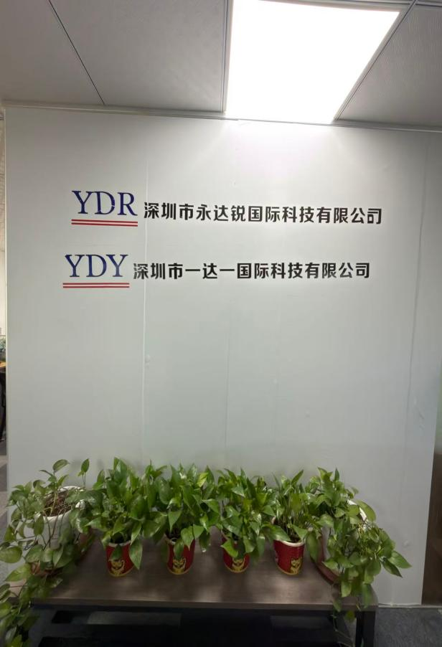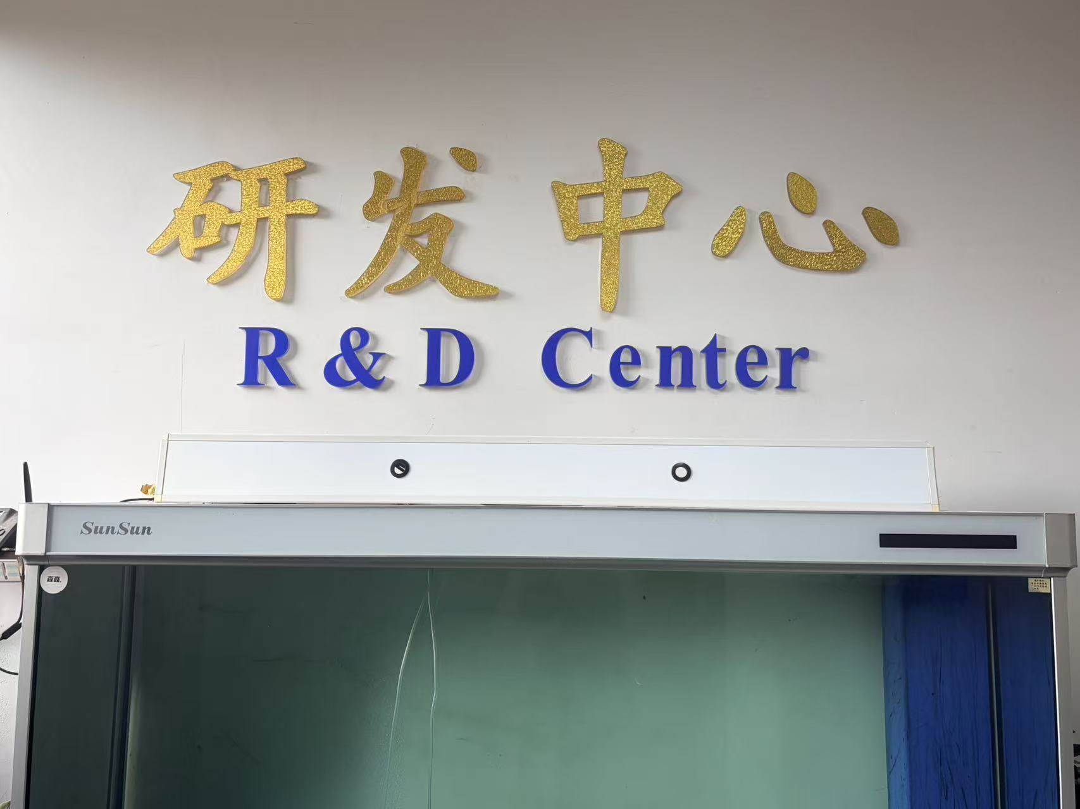

PRODUCT CATALOG产品目录

5D铂金电铸设备及材料+技术培训5D Platinum Electroforming Equipment, Materials & Technical Training

无氰5D硬金电铸设备及材料+技术培训
Cyanide-Free 5D Hard Gold Electroforming Equipment, Materials & Technical Training

无氰5D硬银电铸设备及材料+技术培训
Cyanide-Free 5D Hard Silver Electroforming Equipment, Materials & Technical Training

首饰无氰21K，22K电铸设备及材料+技术培训
Cyanide-Free 21K & 22K Gold Jewelry Electroforming Equipment, Materials & Technical Training

首饰无氰14K，18K电铸设备及材料+技术培训Cyanide-Free 14K & 18K Gold Jewelry Electroforming Equipment, Materials & Technical Training

绒毛金电铸设备及材料+技术培训
Velvet Gold Electroforming Equipment, Materials & Technical Training

黑钌电镀工艺及材料+技术培训Black Ruthenium Electroplating Technology, Materials & Technical Training

蓝色铑电镀工艺及材料+技术培训Blue Rhodium Electroplating Technology, Materials & Technical Training

公司其他设备图介绍Electrolytic coloration of titanium

5D铂金电铸设备及材料+技术培训5D Platinum Electroforming Equipment, Materials & Technical Training
●目前市面上的铂金饰品结构都较为单一，而使用类似3D硬金电铸的方式生产铂金制品之前一直是个未能解决的难题。经过我们研发团队的不懈努力终于攻克了这个技术难题，为铂金制品生产提供了新的工艺，必将开创铂金首饰的新潮流。
●Currently, platinum jewelry products on the market have relatively simple designs. Producing platinum jewelry using a process similar to 3D hard gold electroforming has long been considered a technical challenge.After continuous research and development, our team has successfully overcome this challenge and developed a new 5D platinum electroforming technology, providing an innovative production solution for platinum products and creating new possibilities for the future of platinum jewelry design.

工艺 特色 process Features
●(1)工艺成熟，稳定性高，适合工业化生产。 Mature technology with high stability, suitable for industrial-scale production.
●(2)成色高，达到99.9%以上。High purity, achieving over 99.9% platinum content.
●(3)无氰环保，不含剧毒氰化物。Cyanide-free and environmentally friendly, containing no highly toxic cyanide compounds.

相关材料 Related Materials & Equipment
●(1)开缸剂make up solution，
●(2)光泽剂Brightener
●(3)导电盐Conductive salt
●(4)铂金盐+铂金盐制作技术培训Platinum salt + platinum salt preparation technical training
●(5)铂金电铸机Platinum electroforming machine

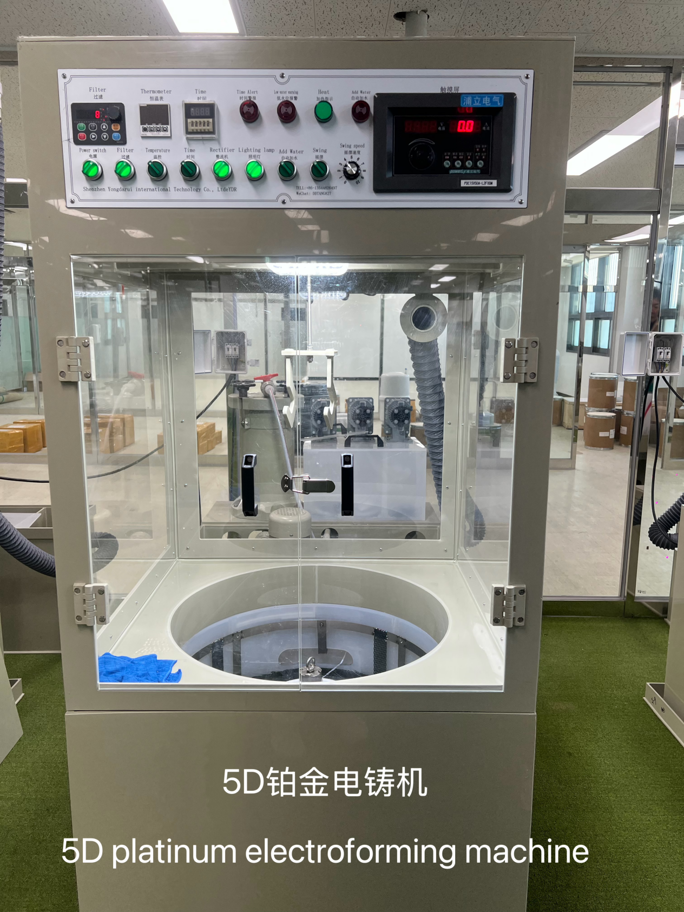
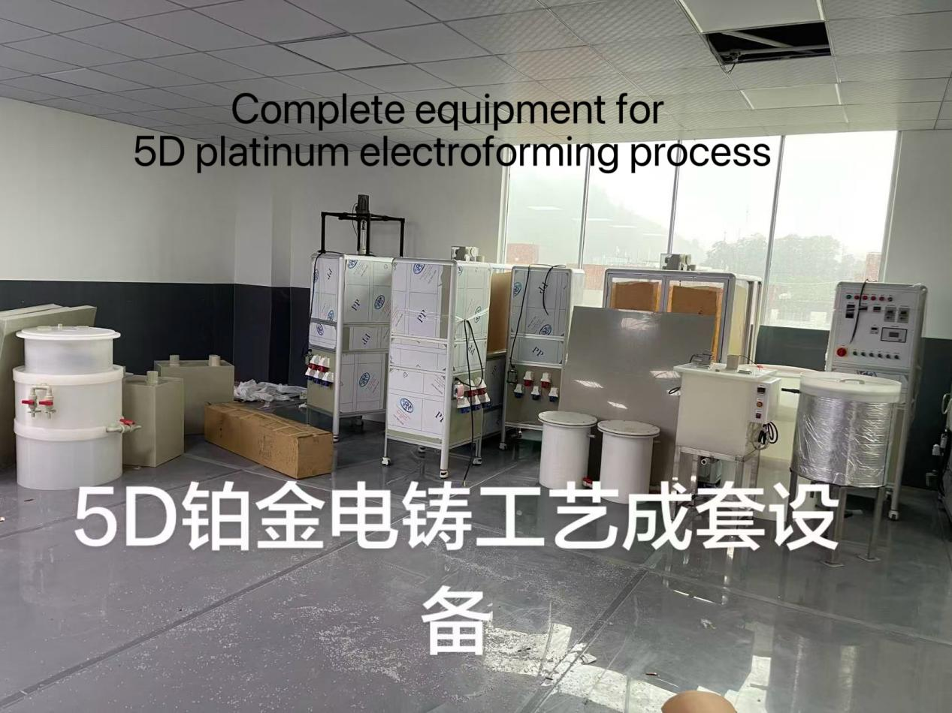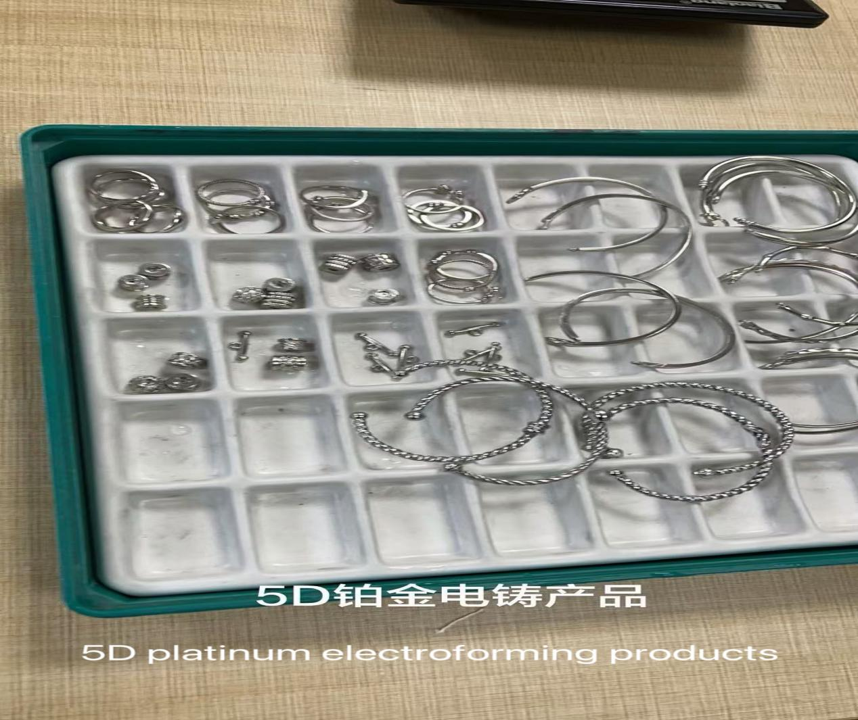
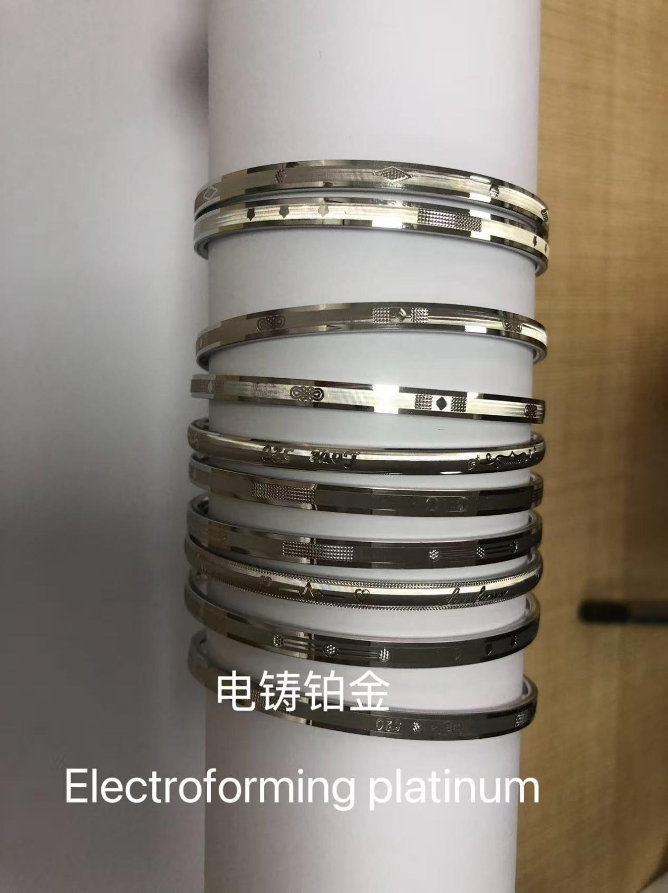

无氰5D硬金电铸设备及材料+技术培训
Cyanide-Free 5D Hard Gold Electroforming Equipment, Materials & Technical Training

工艺 介绍Process Introduction
● 5D硬金是近些年来珠宝首饰行业流行的一种99.9纯黄金制品。传统的工艺需要使用大量的氰化钾，而我们的无氰5D硬金工艺是一种真正的无任何氰化物的环保工艺。
●5D hard gold is a popular 99.9% pure gold product in the jewelry industry in recent years. Traditional production methods require the use of a large amount of potassium cyanide (KCN).Our cyanide-free 5D hard gold electroforming technology is a truly environmentally friendly process that contains no cyanide compounds, providing a safer and more sustainable solution for gold jewelry manufacturing.

工艺 特色Process Features
●(1)工艺成熟，稳定性高，适合工业化生产。Mature technology with high stability, suitable for industrial-scale production.
●(2)成色高，达到99.9%以上。High purity, achieving over 99.9% gold content.
●(3)硬度高，可到达120HV以上。High hardness, reaching over 120 HV.
●(4)无氰环保，不含剧毒氰化物。Cyanide-free and environmentally friendly, containing no highly toxic cyanide compounds.
●(5)污水处理简单。Simple wastewater treatment process.

相关 材料Related Materials & Equipment
●(1)开缸剂 make up solution
●(2)光泽剂Brightener
●(3)导电盐Conductive salt
●(4)金补充剂+金水制作技术培训Gold replenishing agent + gold solution preparation technical training
●(5)5D硬金电铸机5D hard gold electroforming machine
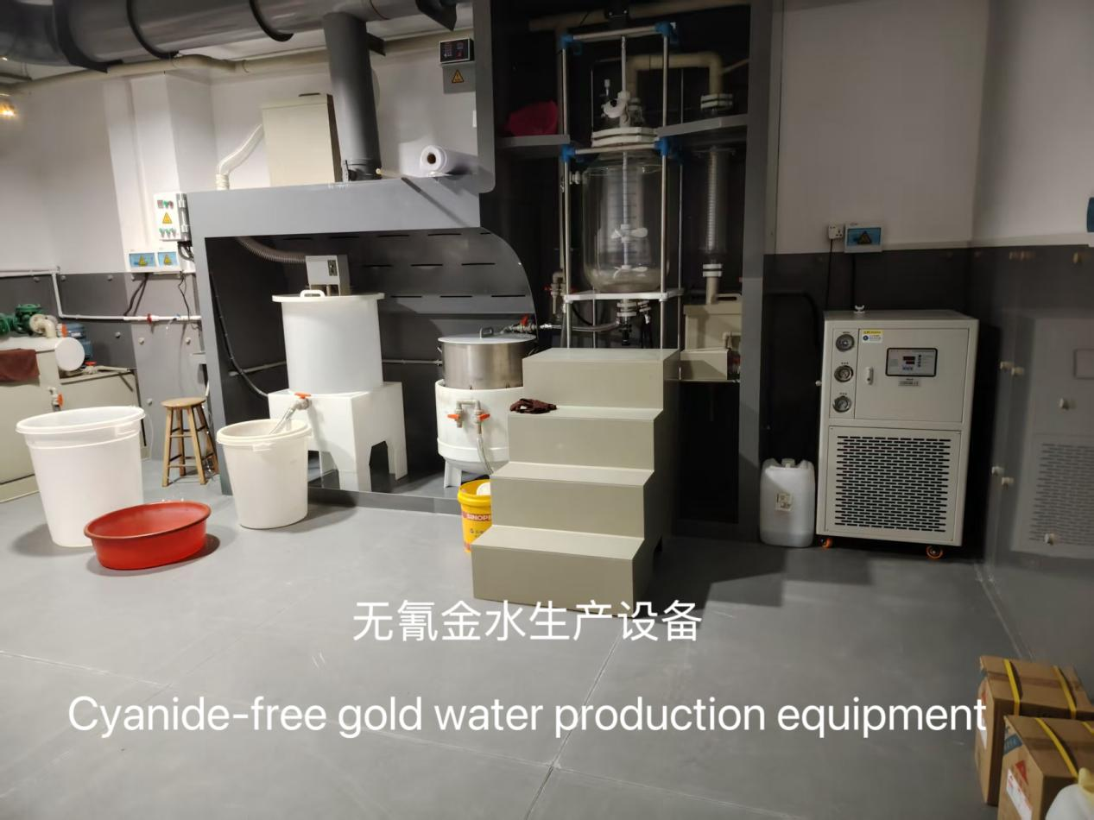

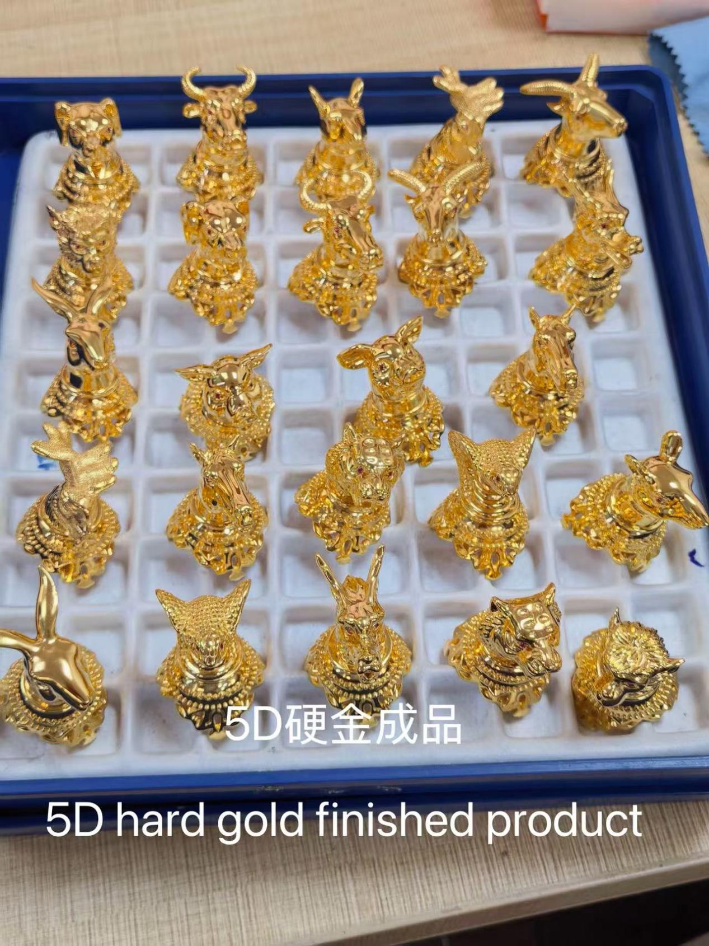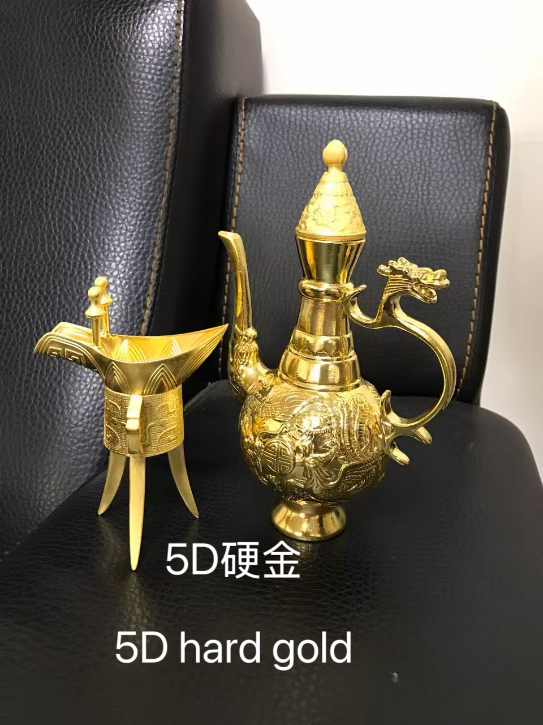
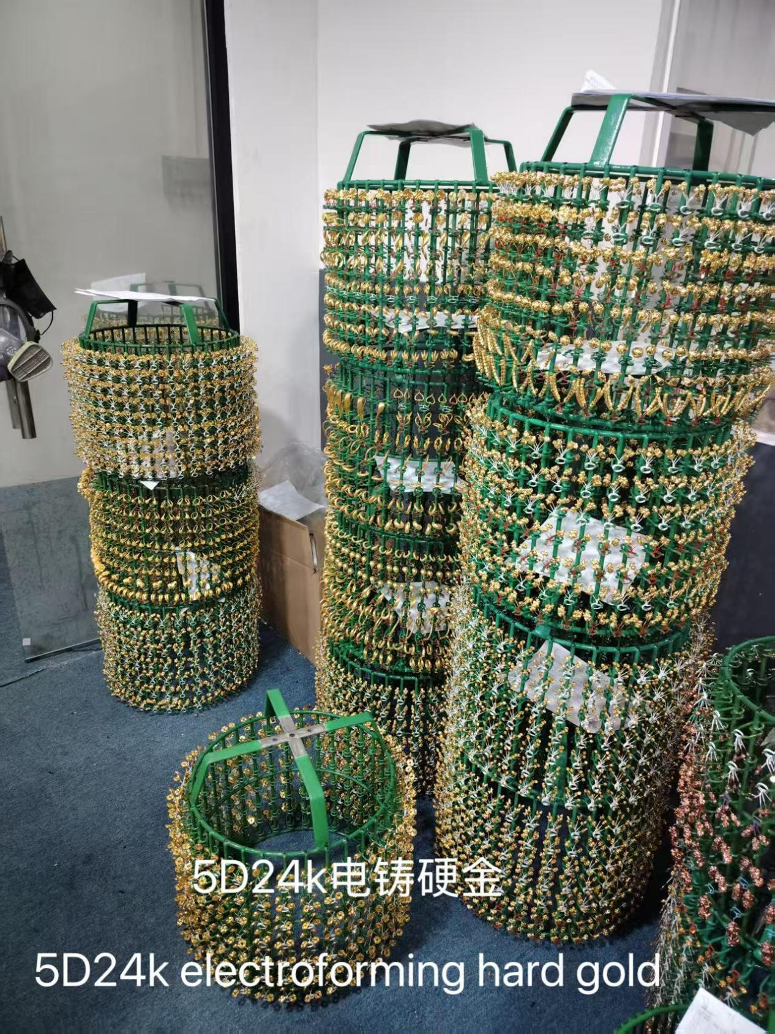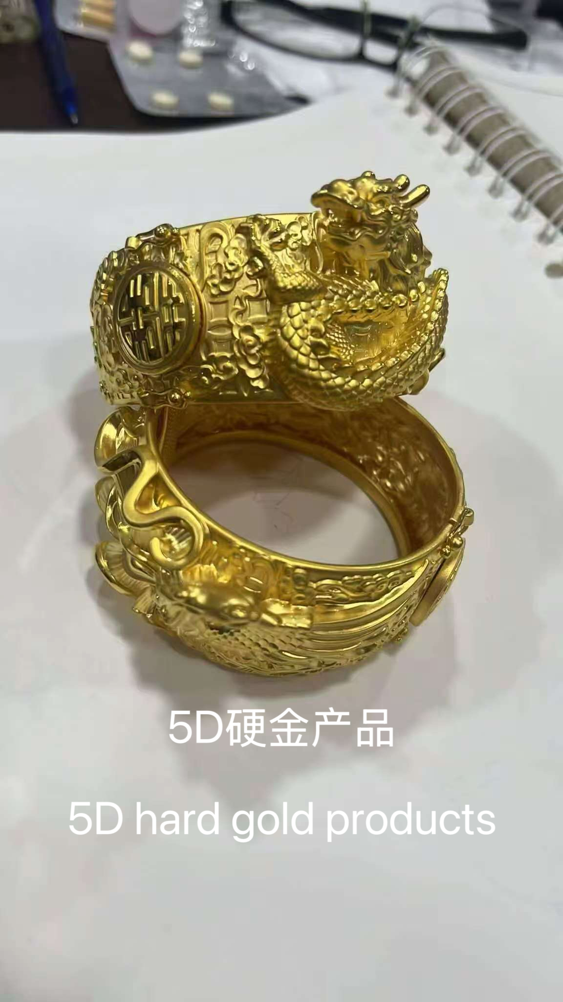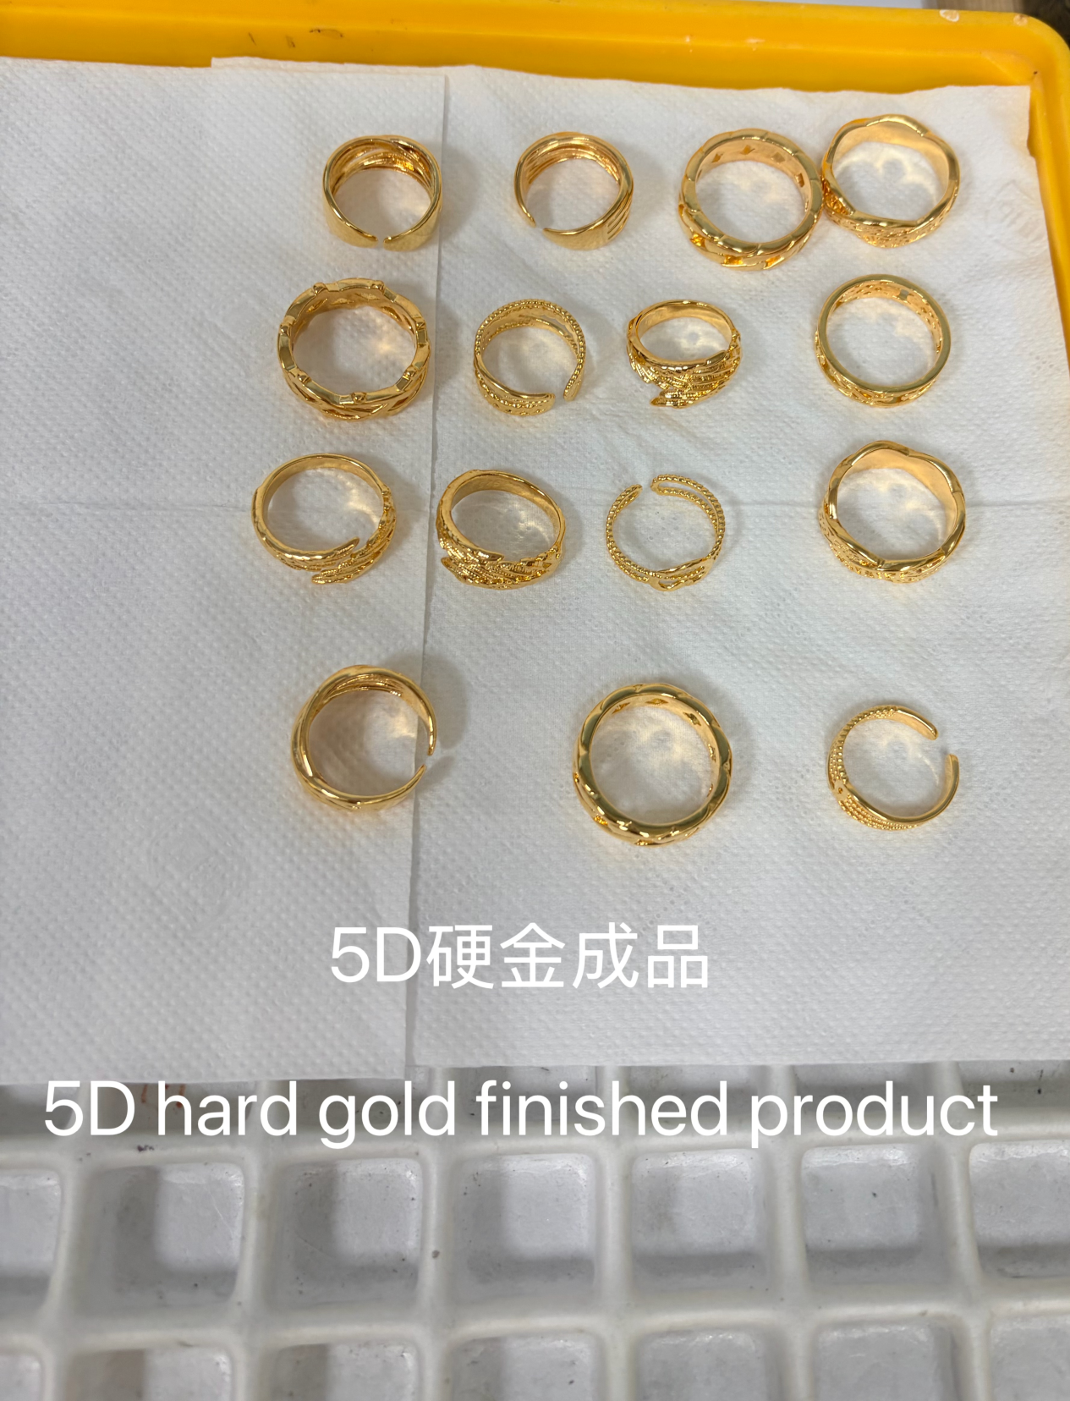

无氰5D硬银电铸设备及材料+技术培训
Cyanide-Free 5D Hard Silver Electroforming Equipment, Materials & Technical Training

工艺 介绍Process Introduction
● 无氰5D硬银工艺是一种利用电铸的手段生产立体银制品的过程。用少量的银做出了立体的饰品效果，同质量的银体积是普通银饰4倍，并且解决了银太软的问题，能过到普通银饰3倍的硬度。
● Cyanide-free 5D hard silver electroforming technology is a process that uses electroforming methods to produce three-dimensional silver products.y using a small amount of silver, this technology creates a three-dimensional jewelry effect. Compared with traditional silver jewelry, products with the same weight can achieve approximately 4 times the volume, while also solving the softness issue of silver and achieving 3 times the hardness of conventional silver jewelry.

工艺 特色Process Introduction
●(1)工艺成熟，稳定性高，适合工业化生产。Mature technology with high stability, suitable for industrial-scale production.
●(2)成色高，达到99.9%以上。High purity, achieving over 99.9% silver content.
●(3)硬度高，可到达130HV以上。High hardness, reaching over 130 HV.
●(4)不含砷、铅、镉等有害金属。Free from harmful metals such as arsenic, lead, and cadmium.
●(5)无氰环保，不含剧毒氰化物。Cyanide-free and environmentally friendly, containing no highly toxic cyanide compounds.
●(6)污水处理简单。Simple wastewater treatment process.

相关 材料Related Materials & Equipment
●(1)开缸剂make up solution
●(2)光泽剂Brightener
●(3)导电盐Conductive salt
●(4)硝酸银生产技术培训Silver nitrate production technical training
●(5)无氰5D硬银电铸机Cyanide-free 5D hard silver electroforming machine
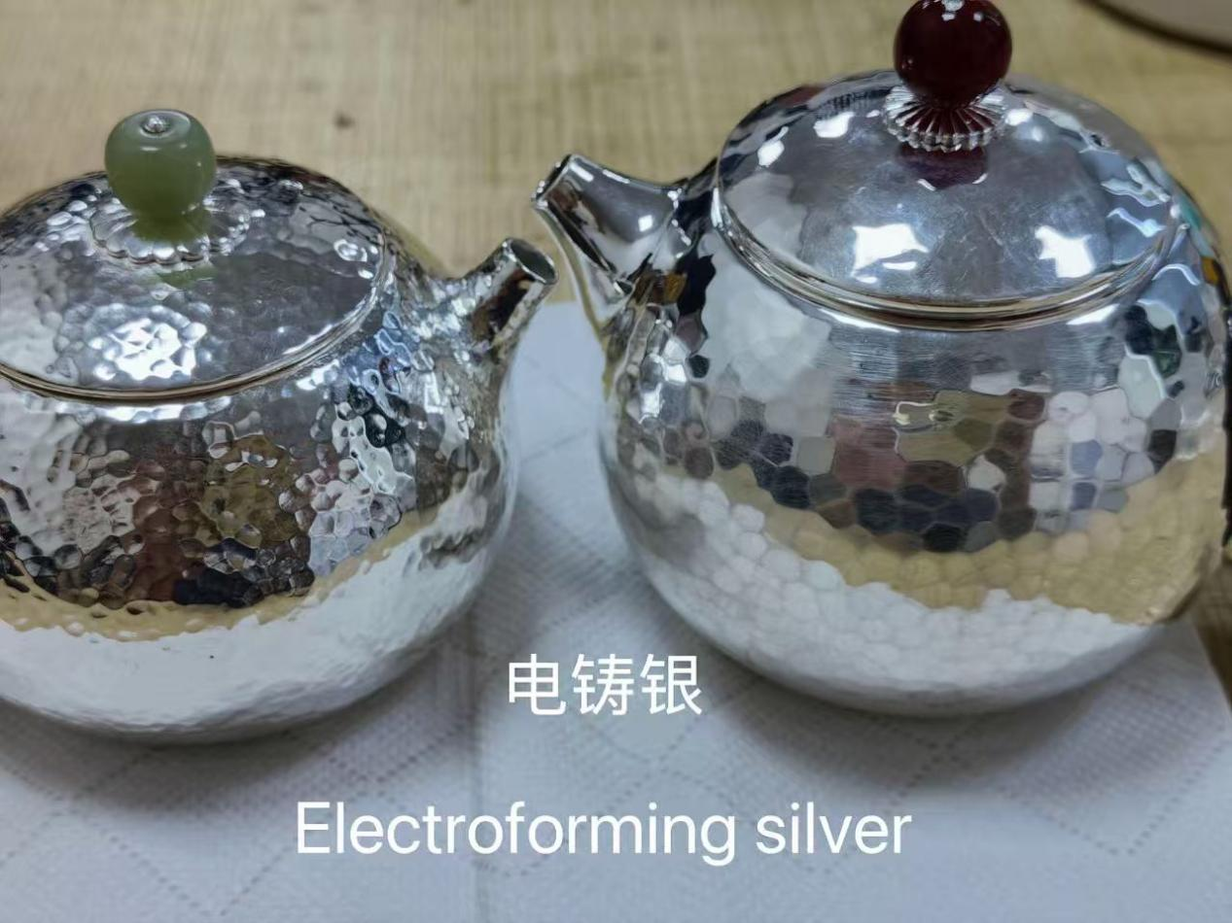
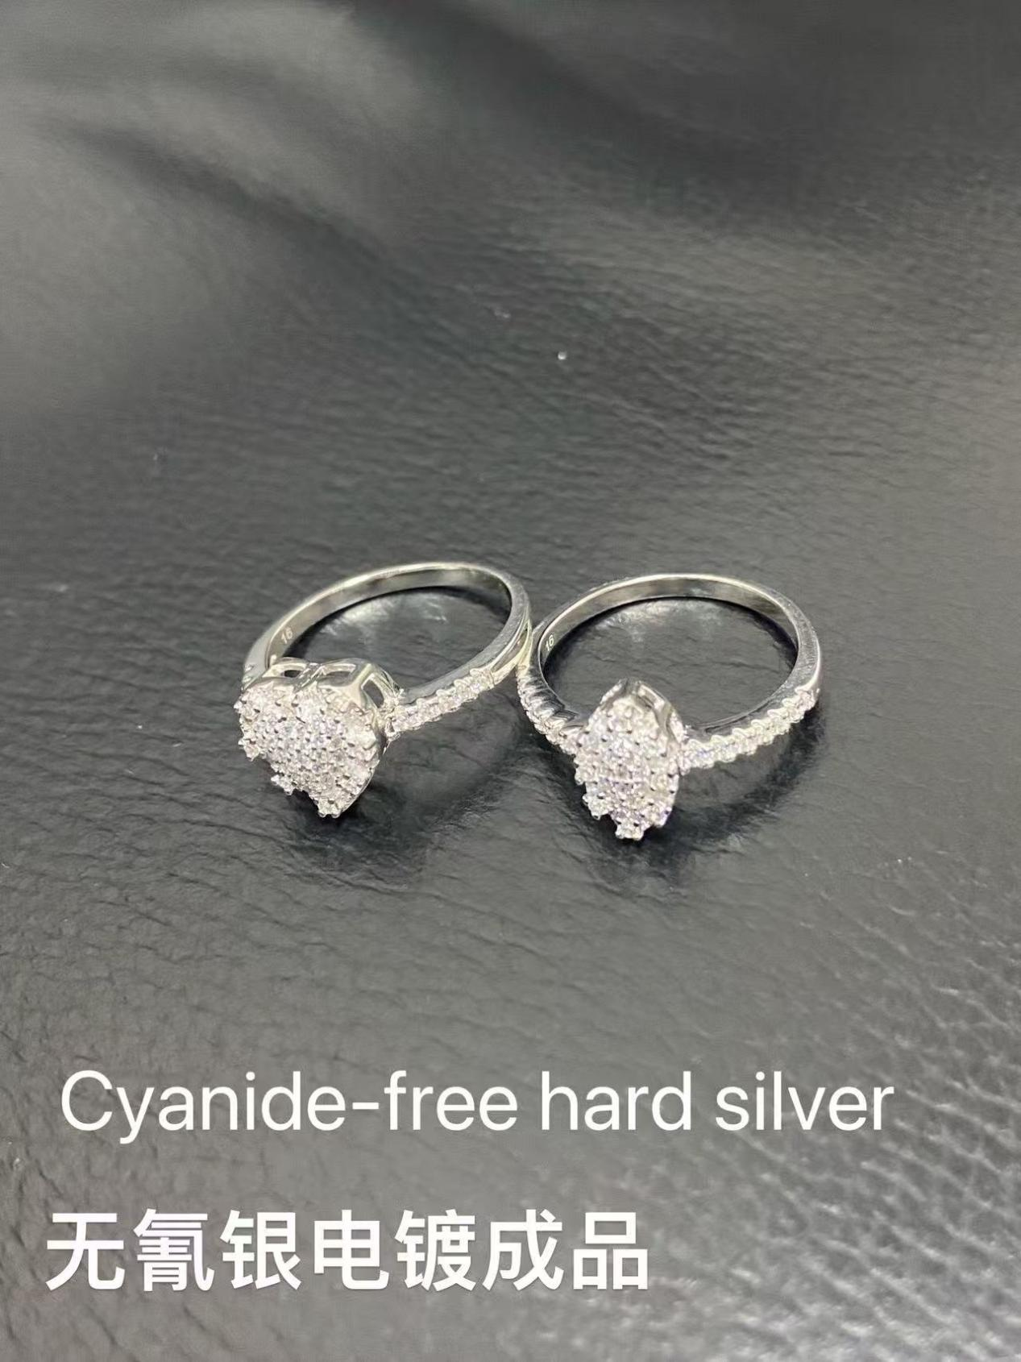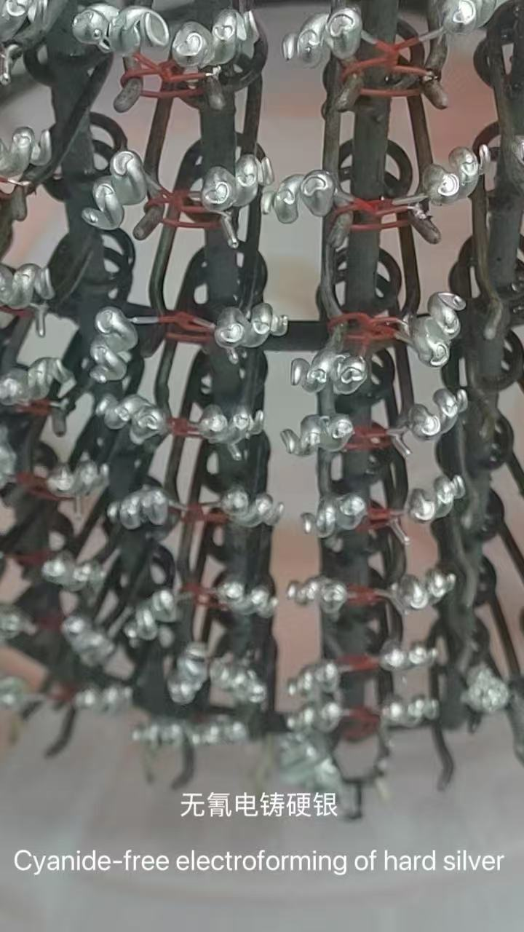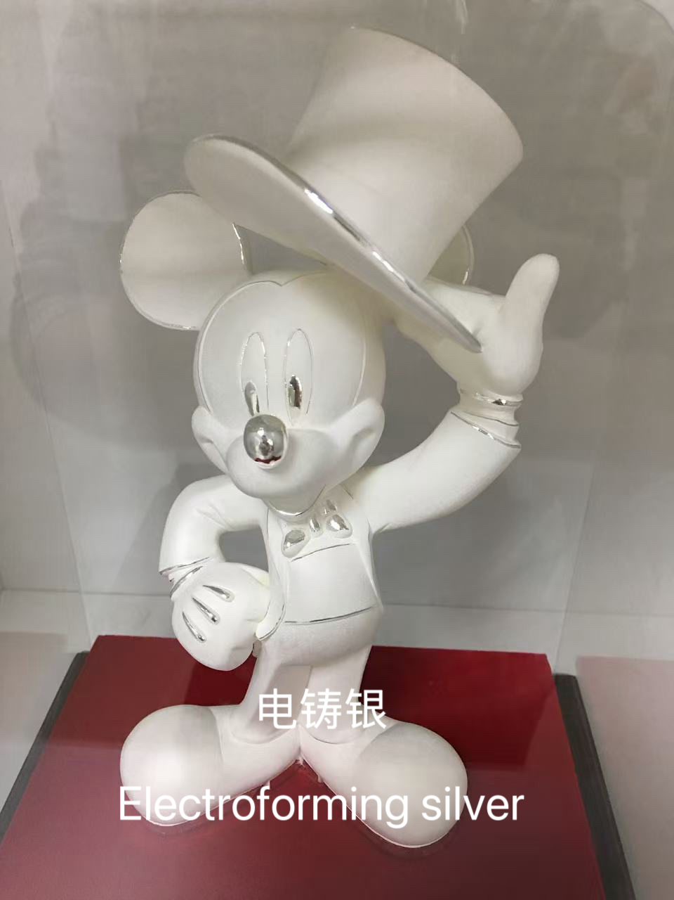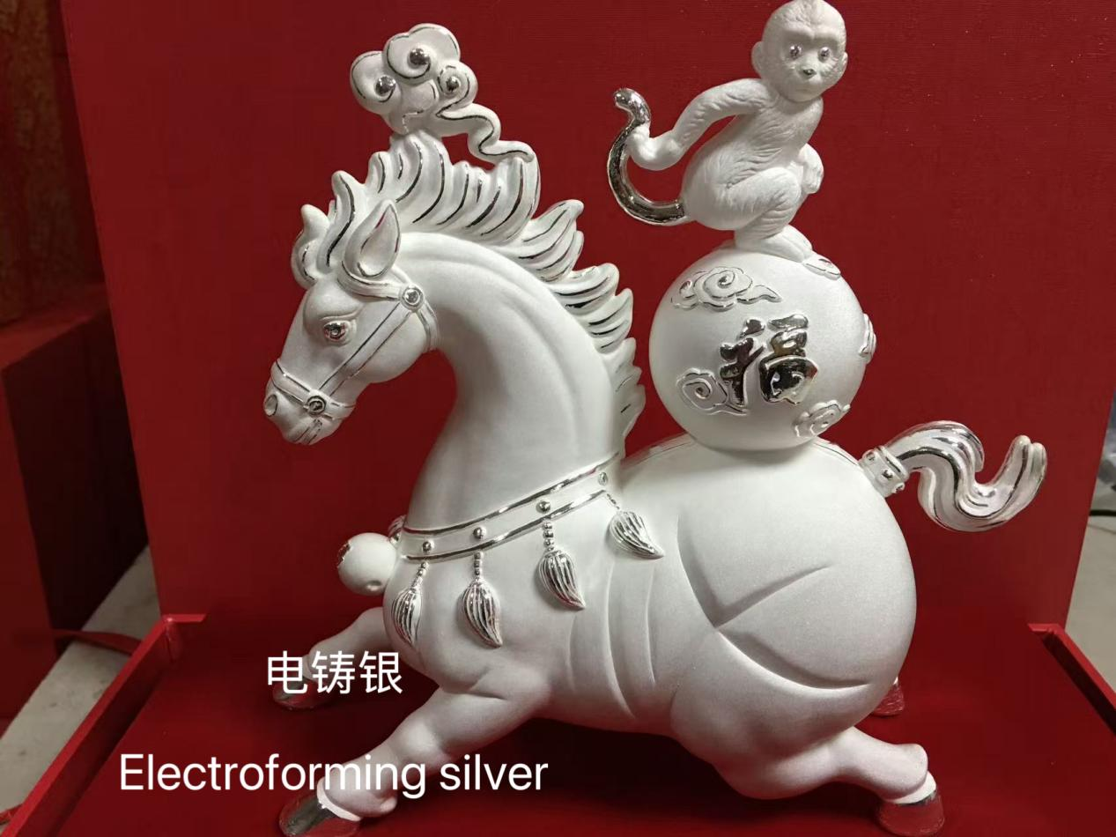

首饰无氰21K，22K电铸设备及材料+技术培训
Cyanide-Free 21K & 22K Gold Jewelry Electroforming Equipment, Materials & Technical Training

工艺 介绍Process Introduction
● 21K,22K无氰电铸工艺，不使用氰化钾，能生产出100微米以上厚度的87.5%,91.6%金镀层的Au-Cu或Au-Cu-In工艺，K值稳定可控。
●Cyanide-free 21K and 22K gold electroforming technology does not use potassium cyanide (KCN). It can produce Au-Cu or Au-Cu-In gold alloy coatings with a thickness of over 100 microns and gold purity of 87.5% (21K) and 91.6% (22K). The K value is stable and controllable.

工艺 特色Process Features
●(1)工艺成熟，无需氰化钾，氰化钠。Mature technology, requiring no potassium cyanide or sodium cyanide.
●(2）87.5%,91.6% K值稳定可控。Stable and controllable K values, achieving 87.5% and 91.6% gold content.
●(3)无氰环保，不含剧毒氰化物。Cyanide-free and environmentally friendly, containing no highly toxic cyanide compounds.
●(4)应用范围广，使用Sn-Bi合金胚。Wide range of applications, using Sn-Bi alloy blanks.
●(5)适合各种规模的生产。Suitable for production at various scales.

相关 材料Related Materials & Equipment
●(1)开缸剂make up solution
●(2)光泽剂Brightener
●(3)无氰络合盐Cyanide-free complexing salt
●(4)PH值调低剂pH adjustment agent
●(5)金补充剂+技术培训Gold replenishing agent + technical training
●(6)21K,22K无氰电铸机Cyanide-free 21K & 22K gold electroforming machine
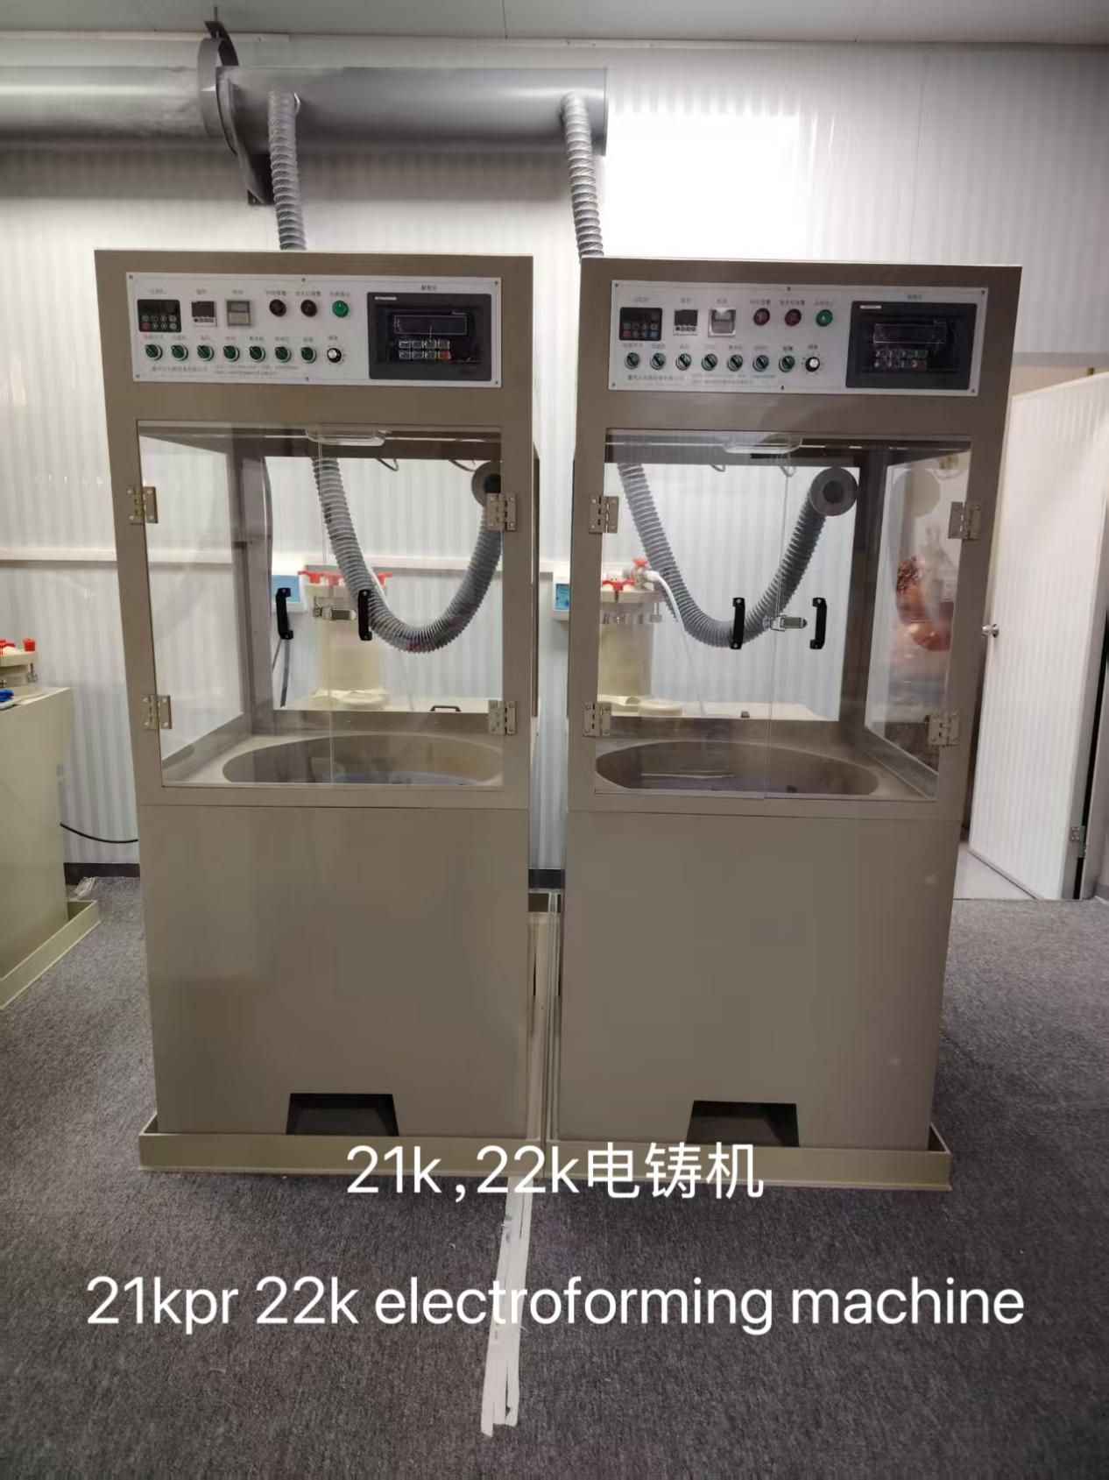
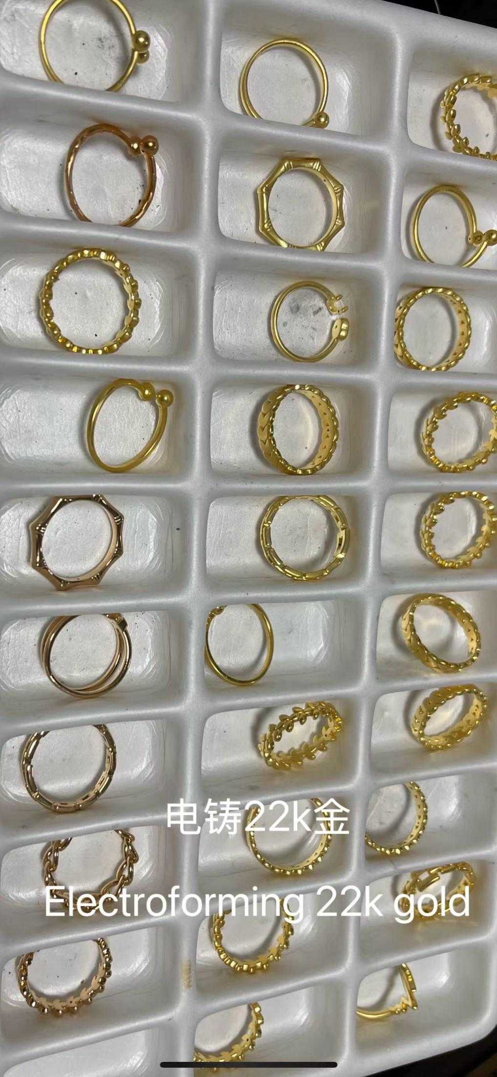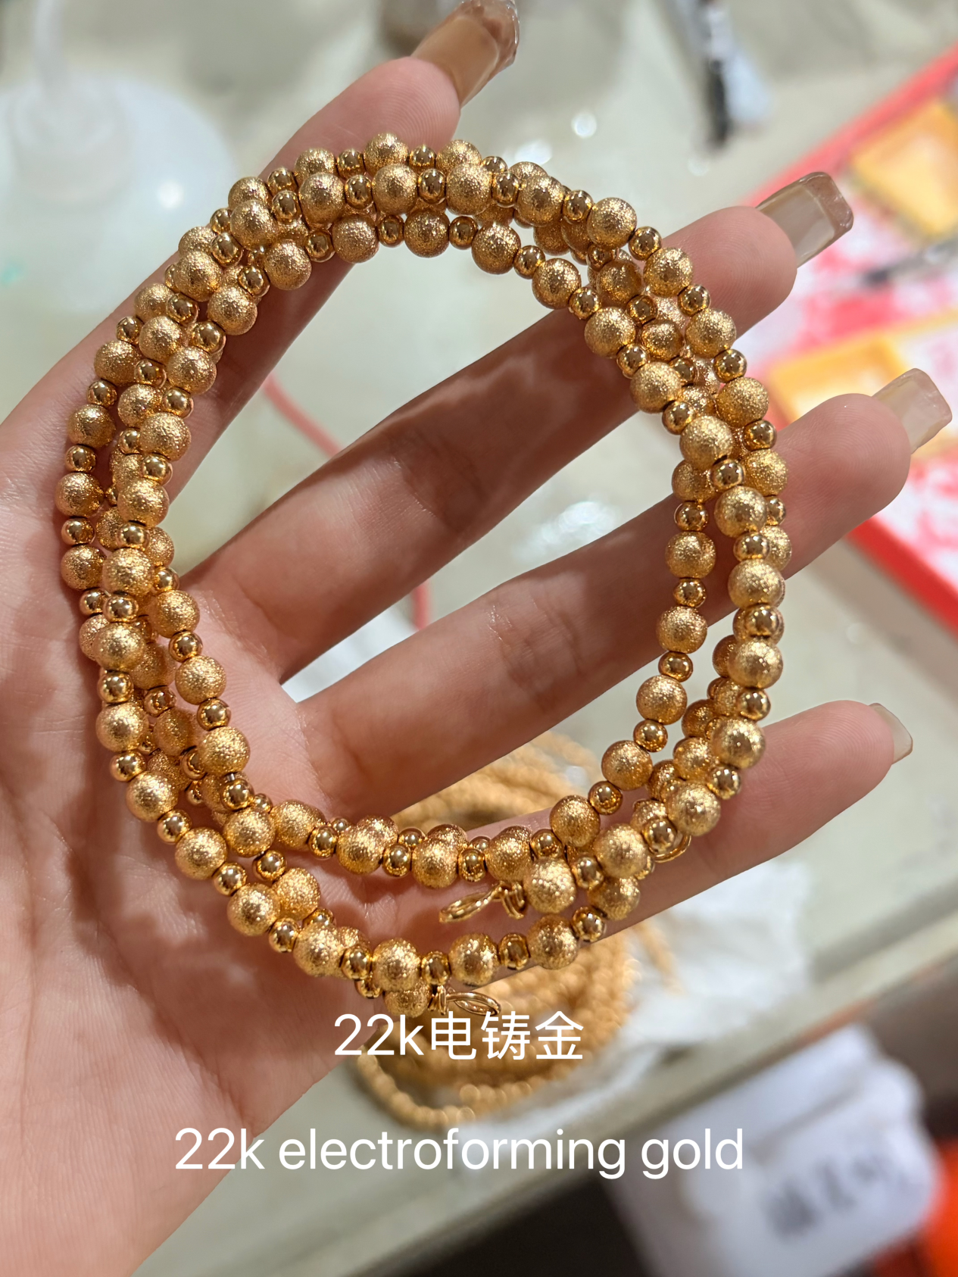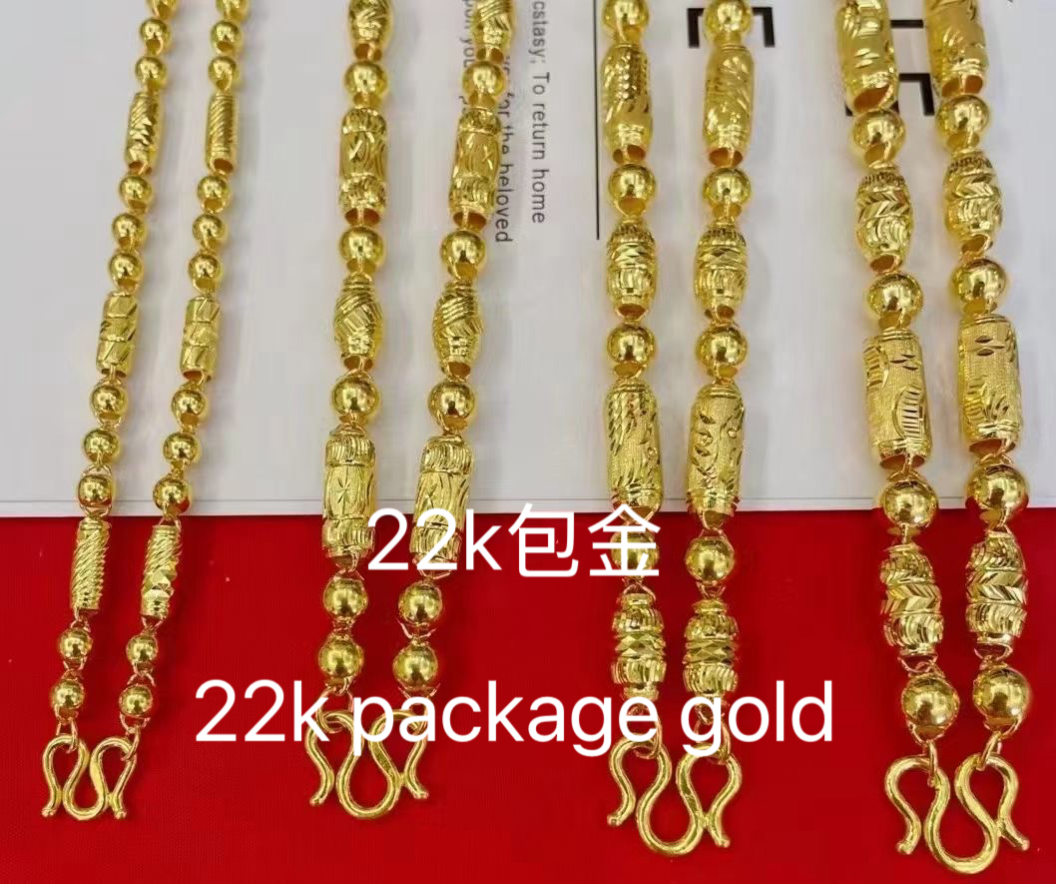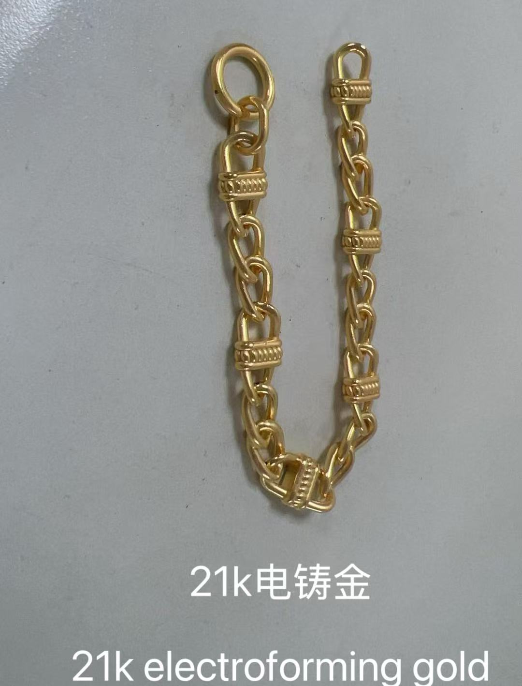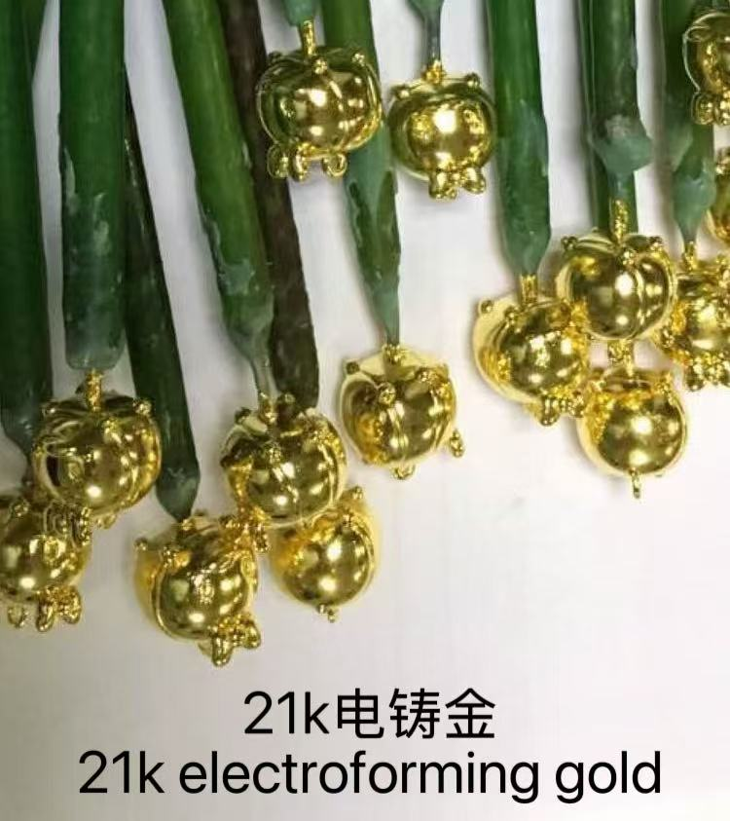

首饰无氰14K，18K电铸设备及材料+技术培训Cyanide-Free 14K & 18K Gold Jewelry Electroforming Equipment, Materials & Technical Training

工艺 介绍Process Introduction
● 14K,18K无氰电铸工艺，不使用氰化钾，能生产出100微米以上厚度的58.5%，75.0%厚金镀层的Au-Cu或Au-Cu-In工艺，K值稳定可控。
●Cyanide-free 14K and 18K gold electroforming technology does not use potassium cyanide (KCN). It can produce Au-Cu or Au-Cu-In gold alloy coatings with a thickness of over 100 microns and gold content of 58.5% (14K) and 75.0% (18K). The K value is stable and controllable.

工艺 特色Process Features
●(1)工艺成熟，无需氰化钾，氰化钠。Mature technology, requiring no potassium cyanide or sodium cyanide.
●(2）58.5%,75.0% K值稳定可控。Stable and controllable K values, achieving 58.5% and 75.0% gold content.
●(3)无氰环保，不含剧毒氰化物。Cyanide-free and environmentally friendly, containing no highly toxic cyanide compounds.
●(4)应用范围广，使用Sn-Bi合金胚。Wide range of applications, using Sn-Bi alloy blanks.
●(5)适合各种规模的生产。Suitable for production at various scales.

相关 材料Related Materials & Equipment
●(1)开缸剂make up solution
●(2)光泽剂Brightener
●(3)无氰络合盐Cyanide-free complexing salt
●(4)PH值调低剂pH adjustment agent
●(5)金补充剂+技术培训Gold replenishing agent + technical training
●(6)14,18K无氰电铸机Cyanide-free 14K & 18K gold electroforming machine
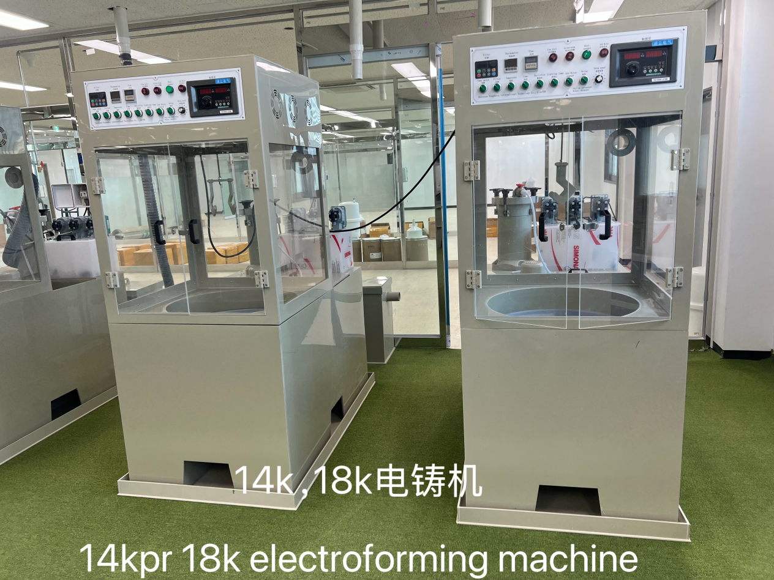
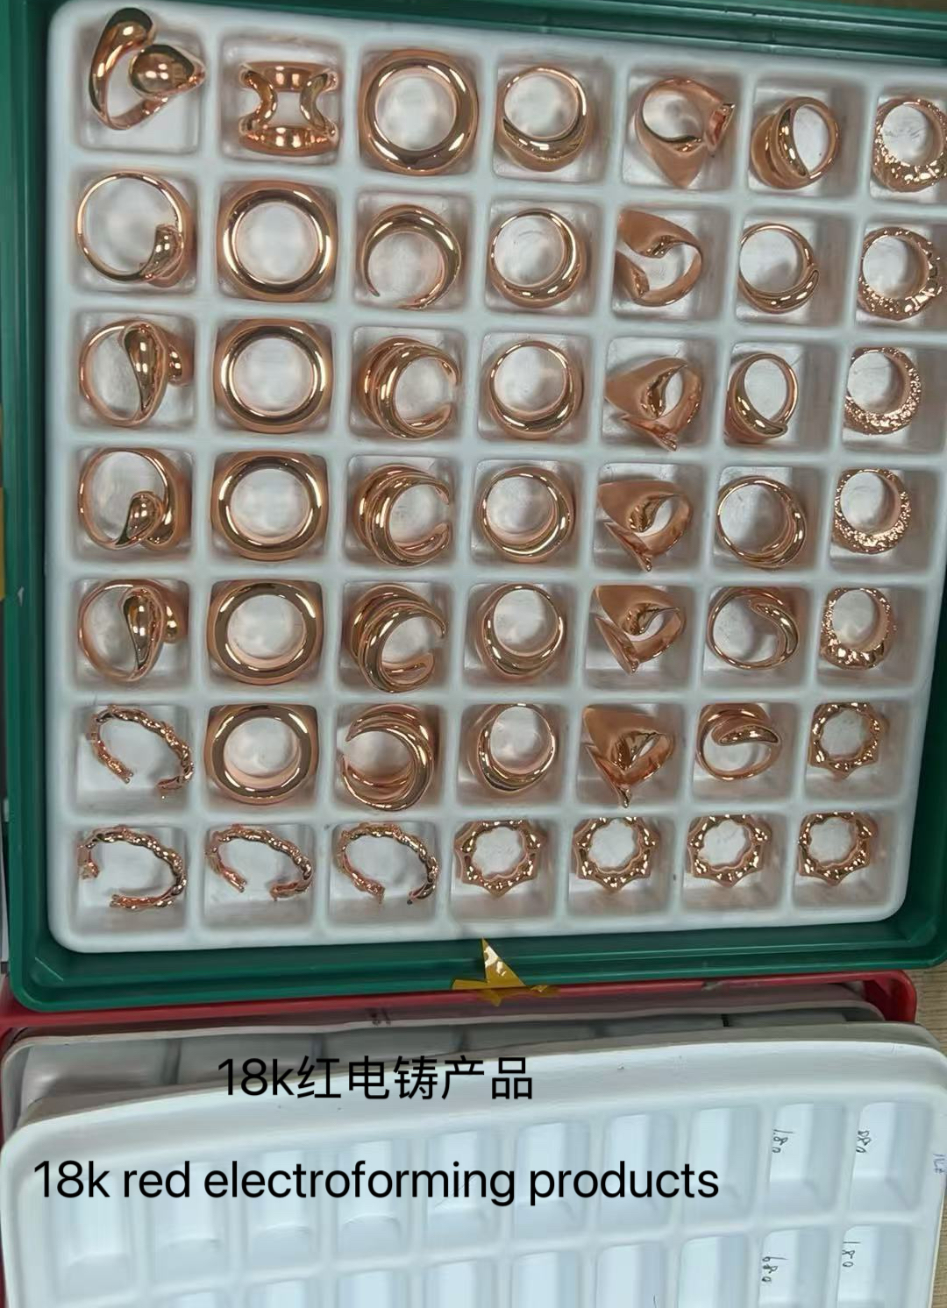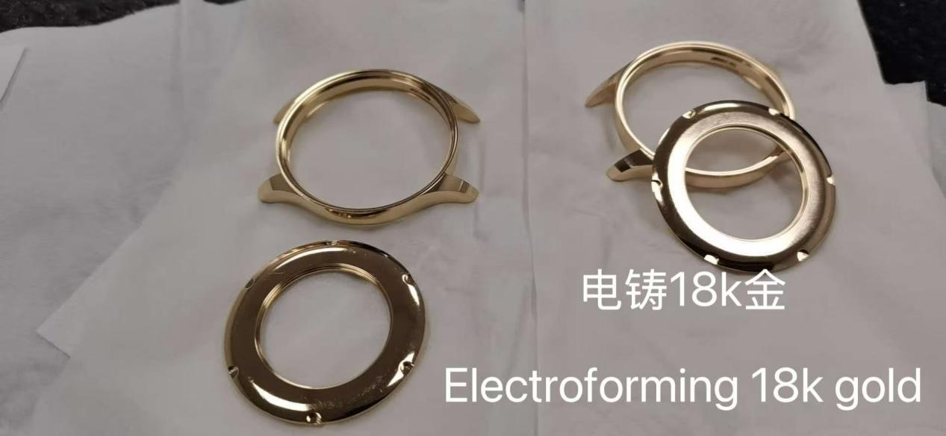
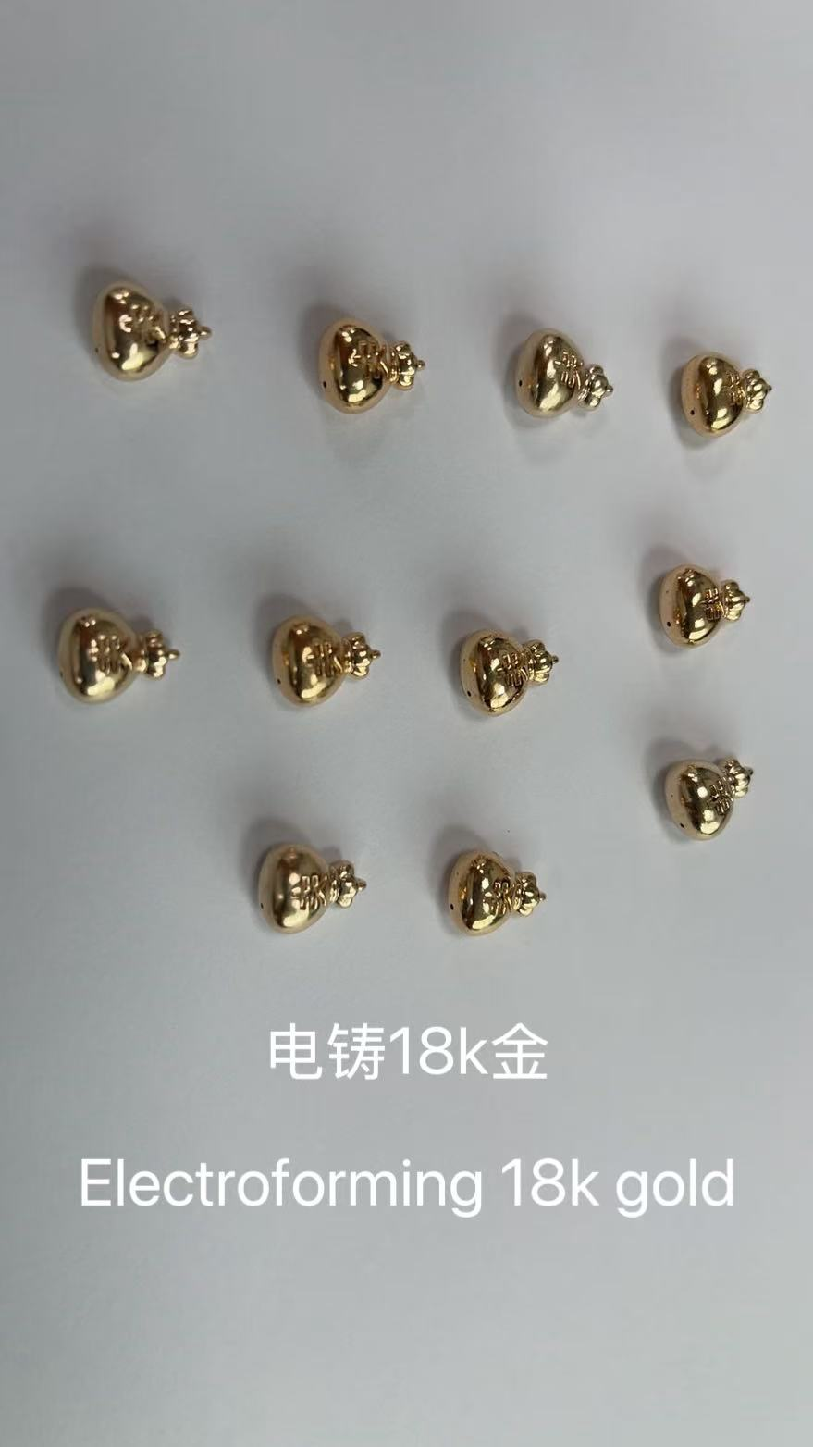

绒毛金电铸设备及材料+技术培训
Velvet Gold Electroforming Equipment, Materials & Technical Training
工艺 介绍Process Introduction
● 纯金工艺品绒毛金电铸工艺，镀层表面是漂亮的绒毛效果，金纯度99.99%，黄金摆设品专用。
●Pure gold decorative products can be produced through velvet gold electroforming technology, creating a beautiful velvet-like surface effect with 99.99% gold purity. It is specially designed for gold decorative items and art pieces.

工艺 特色Process Features
●(1)工艺成熟，无需氰化钾，氰化钠。Mature technology, requiring no potassium cyanide or sodium cyanide.
●(2）金纯度99.99%。High gold purity, reaching 99.99%.
●(3)无氰环保，不含剧毒氰化物。Cyanide-free and environmentally friendly, containing no highly toxic cyanide compounds.
●(4)应用范围广，使用蜡模胚。Wide range of applications, using wax model blanks.
●(5)适合各种规模的生产。Suitable for production at various scales.

相关 材料Related Materials & Equipment
●(1)开缸剂make up solution
●(2)光泽剂Brightener
●(3)无氰络合盐Cyanide-free complexing salt
●(4)PH值调低剂pH adjustment agent
●(5)金补充剂+技术培训Gold replenishing agent + technical training

●(6)绒毛金电铸机Velvet gold electroforming machine

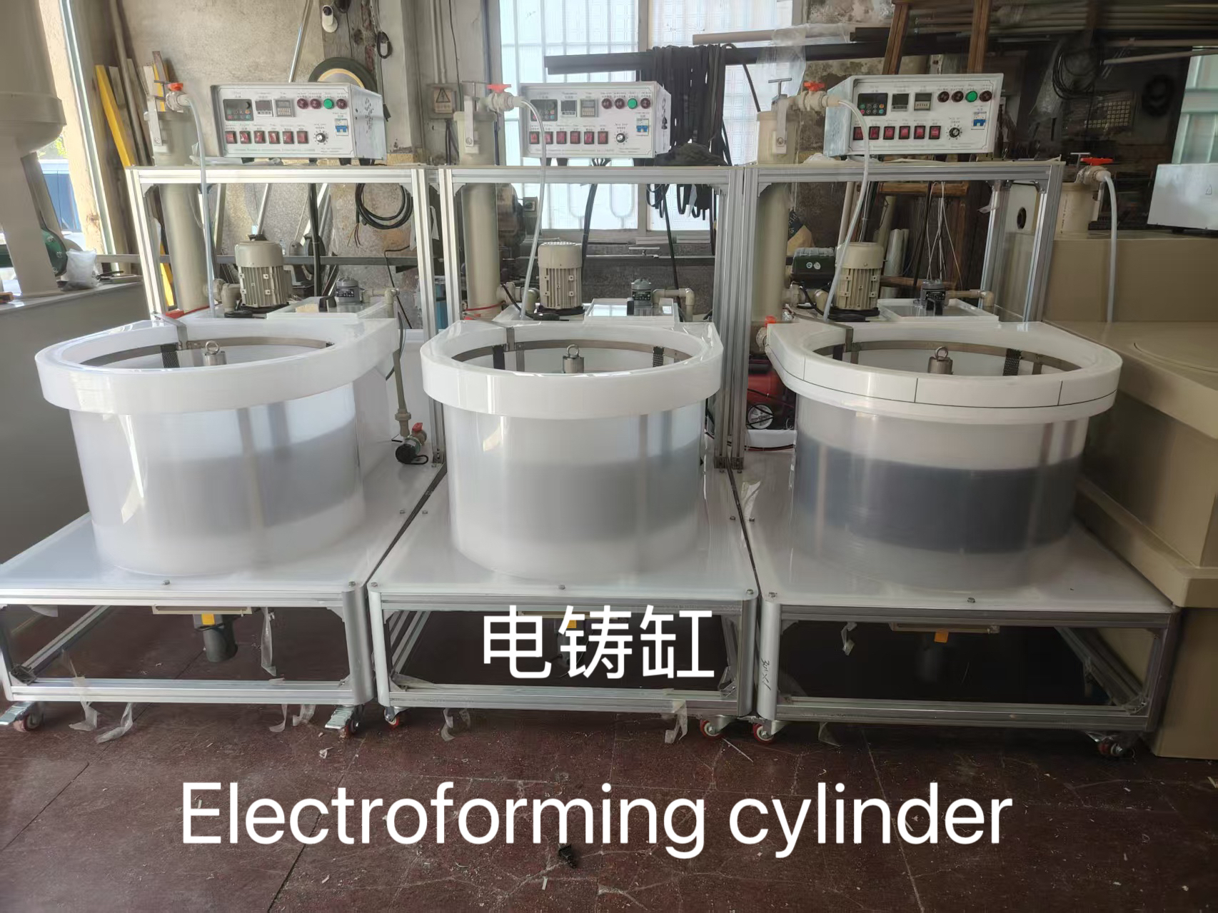

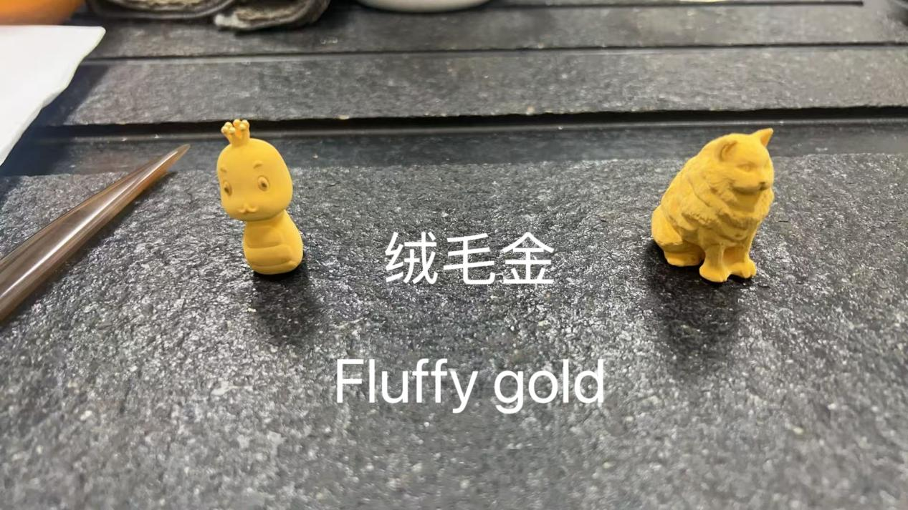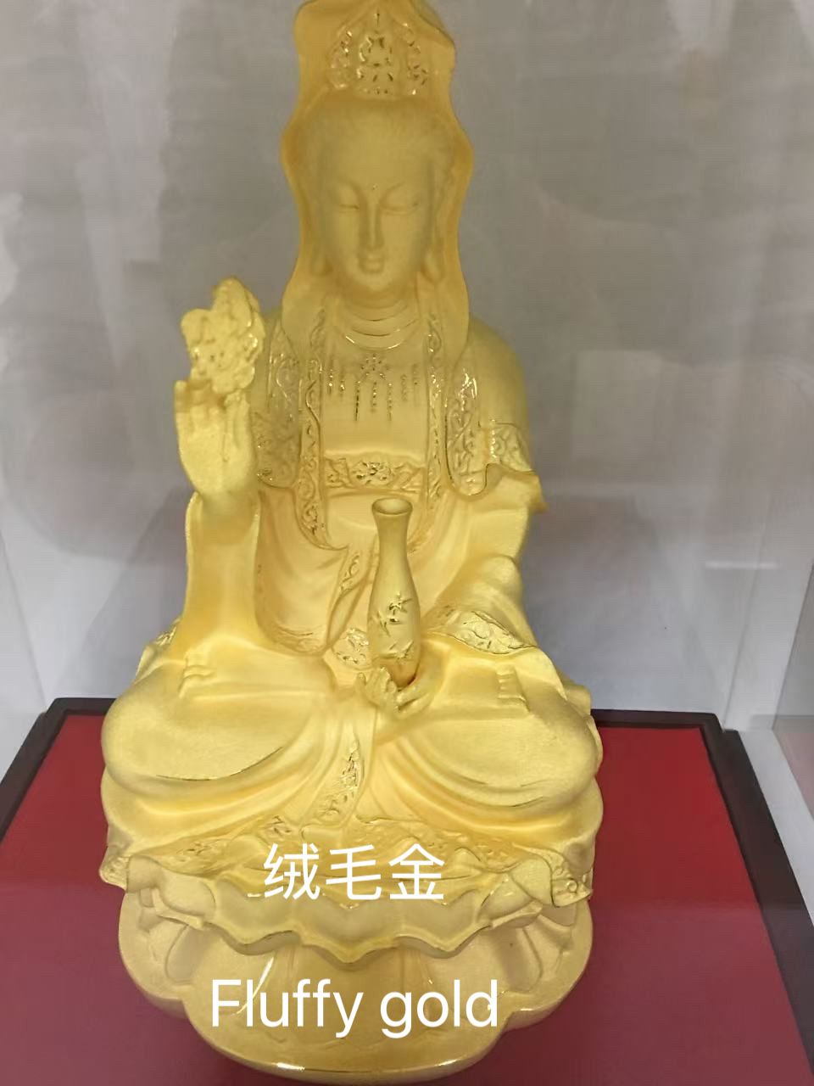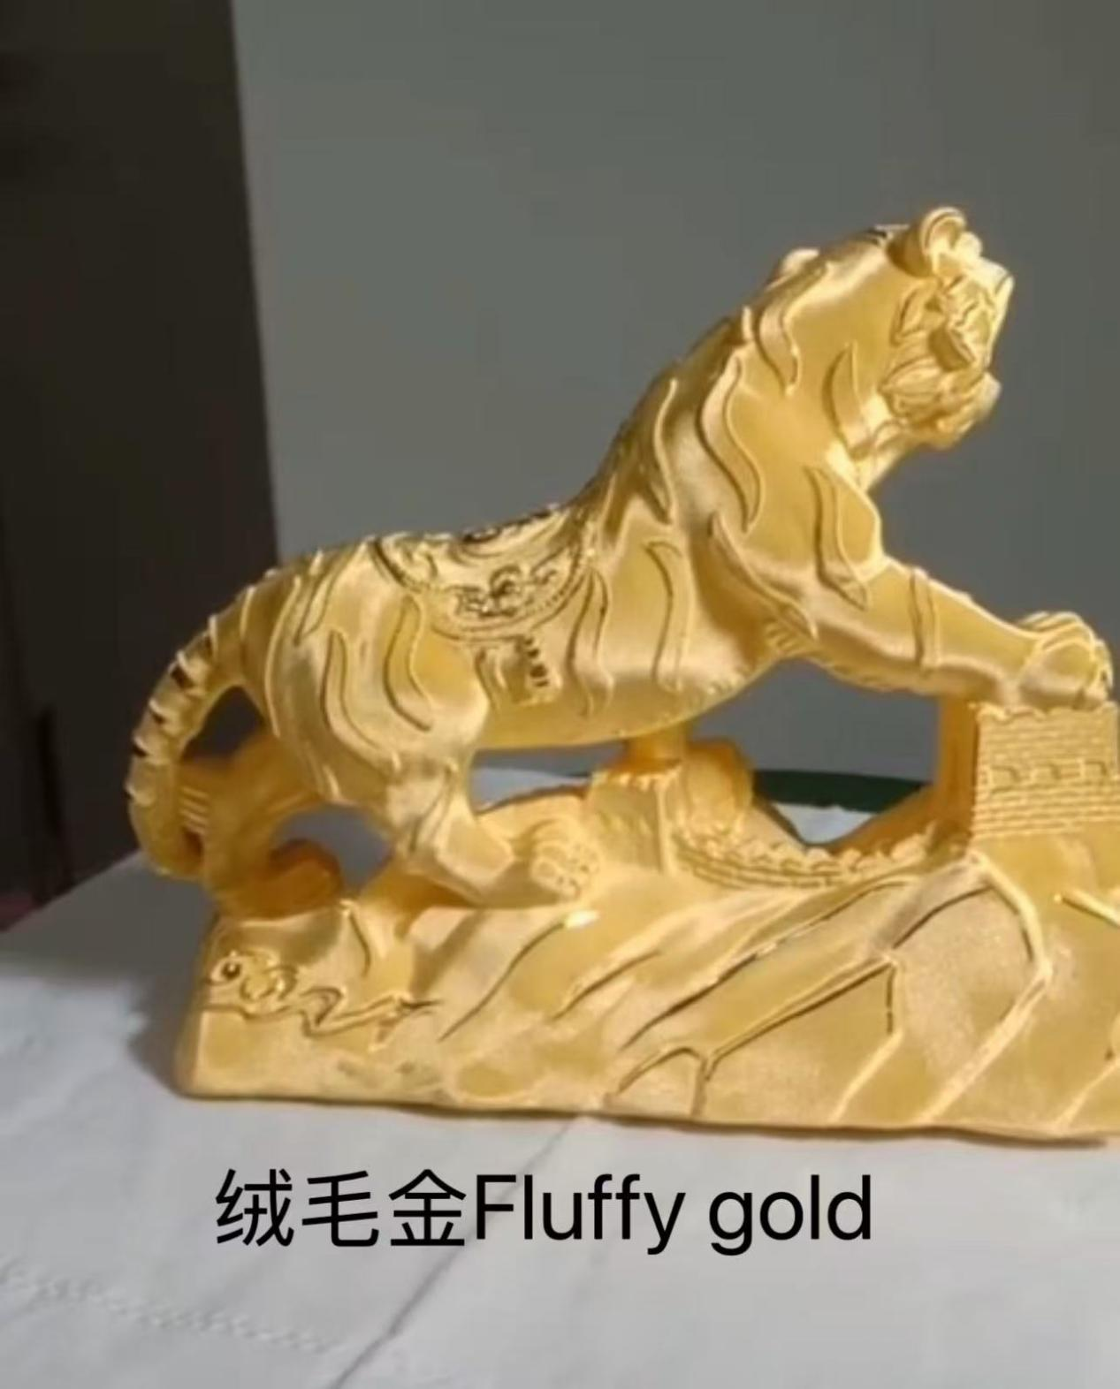

黑钌电镀工艺及材料+技术培训Black Ruthenium Electroplating Technology, Materials & Technical Training

工艺 介绍Process Introduction
● 深黑色钌金表面镀黑色，表面是光亮深黑色，耐变色能力强，首饰黑色色调工艺使用
●Black ruthenium electroplating technology creates a deep black ruthenium surface finish with a bright black appearance and excellent color stability. It is widely used for black-tone finishes in jewelry applications.

工艺 特色Process Features
●(1)工艺成熟，黑色色调稳定。Mature technology with stable black color tone.
●(2）镀层耐磨性好，抗变色。Excellent wear resistance and color stability of the coating.
●(3)无氰环保，不含有害物质。Cyanide-free and environmentally friendly, containing no harmful substances.
●(4)适合各种规模的生产。Suitable for production at various scales.

相关 材料Related Materials & Equipment
●(1)黑钌溶液Black ruthenium solution
●(2)增黑剂Blackening agent
●(3)导电盐Conductive salt
●(5)钌补充剂+技术培训Ruthenium replenishing agent + technical training

●(6)黑色电金机Black electroplating machine

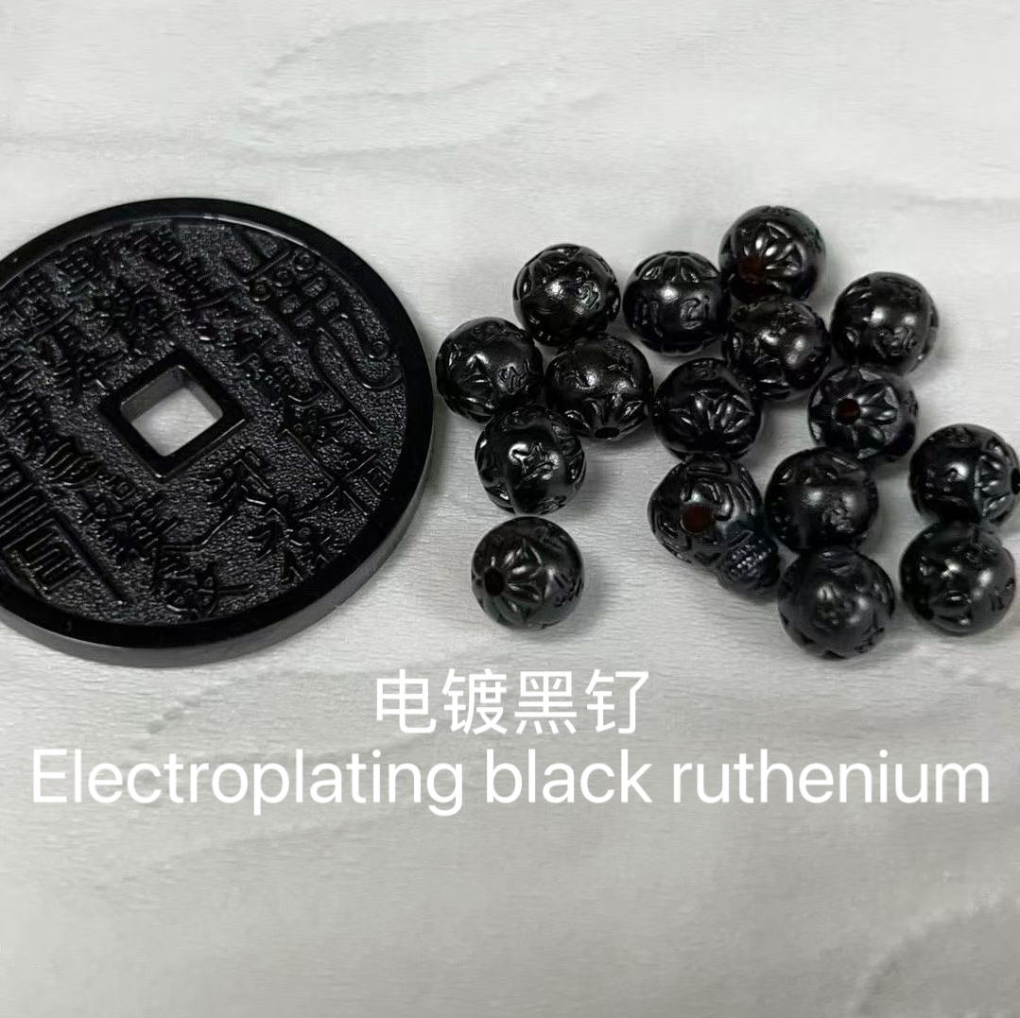

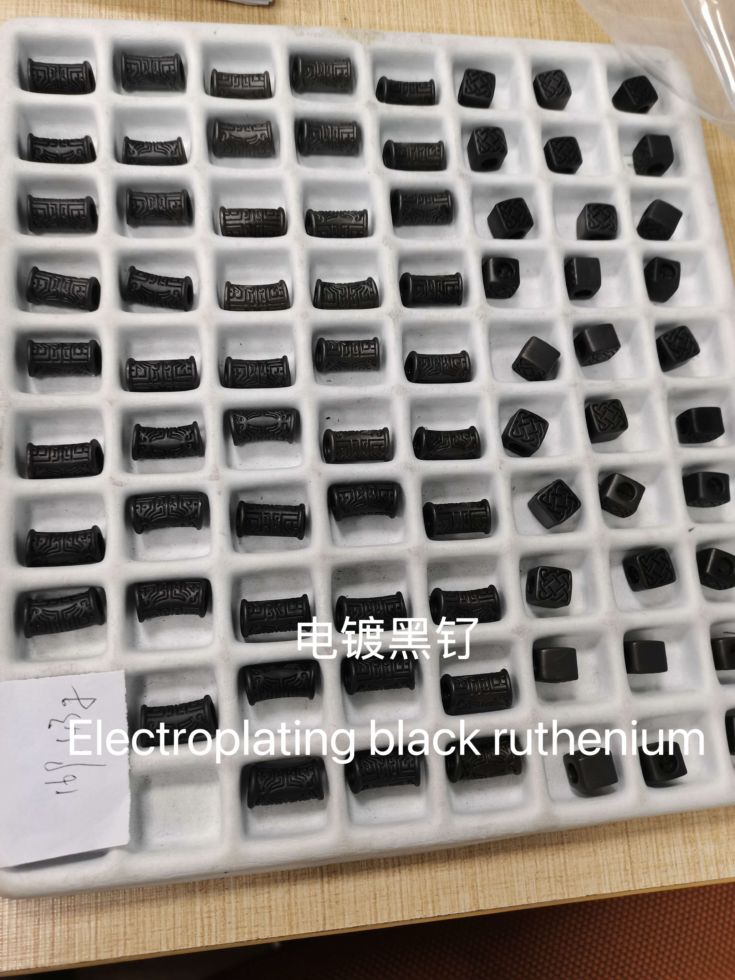

蓝色铑电镀工艺及材料+技术培训Blue Rhodium Electroplating Technology, Materials & Technical Training

工艺 介绍Process Introduction
● 蓝色铑电镀，表面是光亮浅蓝色，耐变色能力强，首饰蓝色色调工艺使用
●Blue rhodium electroplating technology creates a bright light-blue surface finish with excellent color stability. It is widely used for blue-tone finishes in jewelry applications.

工艺 特色Process Features
●(1)工艺成熟，蓝色色调稳定。Mature technology with stable blue color tone.
●(2）镀层耐磨性好，抗变色。Excellent wear resistance and color stability of the coating.
●(3)无氰环保，不含有害物质。Cyanide-free and environmentally friendly, containing no harmful substances.
●(4)适合各种规模的生产。Suitable for production at various scales.

相关 材料Related Materials & Equipment
●(1)蓝铑溶液Blue rhodium solution
●(2)增蓝剂Blue coloring agent
●(3)导电盐Conductive salt
●(5)铑水+技术培训Rhodium solution + technical training

●(6)蓝铑电金机Blue rhodium electroplating machine

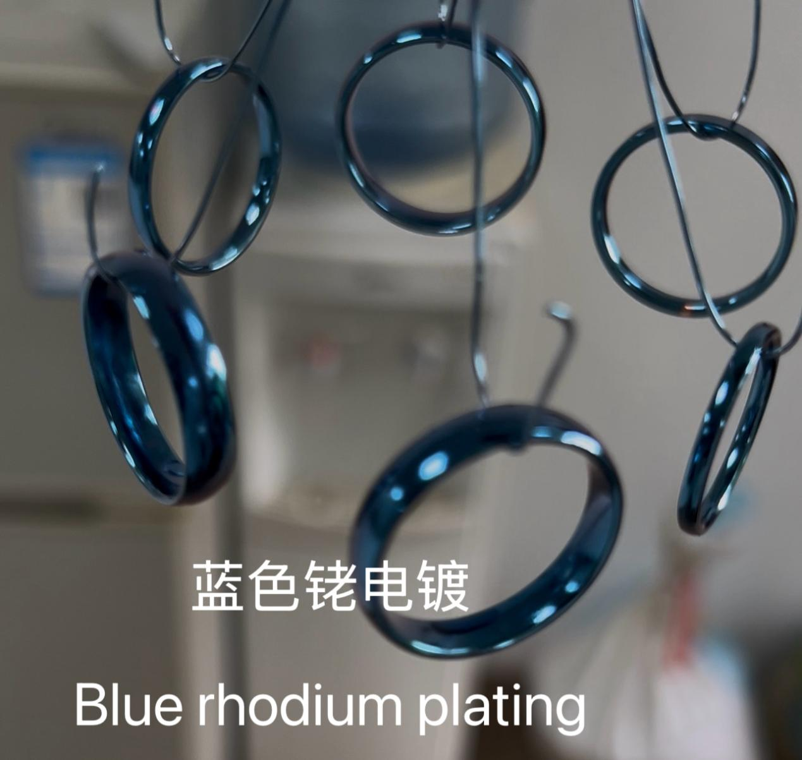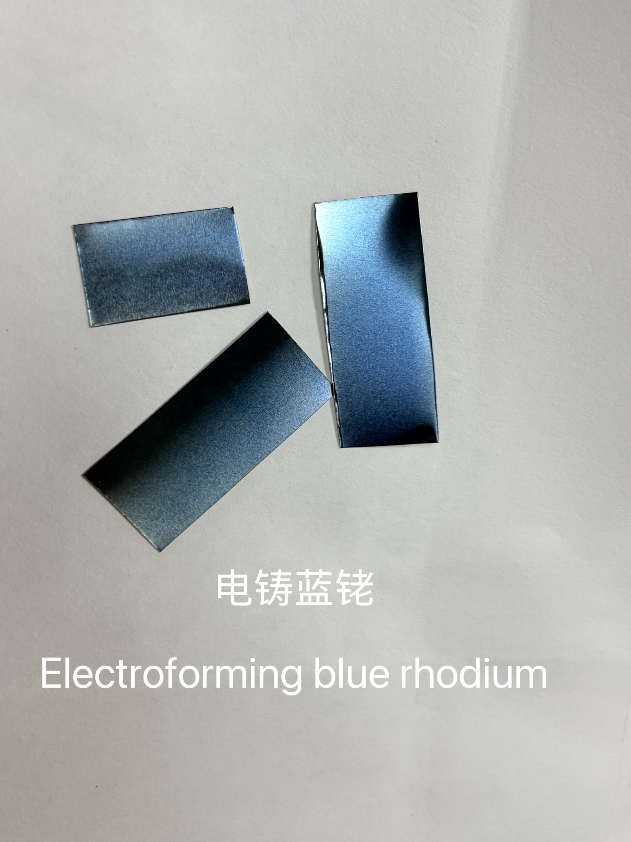

公司其他设备图介绍Electrolytic coloration of titanium

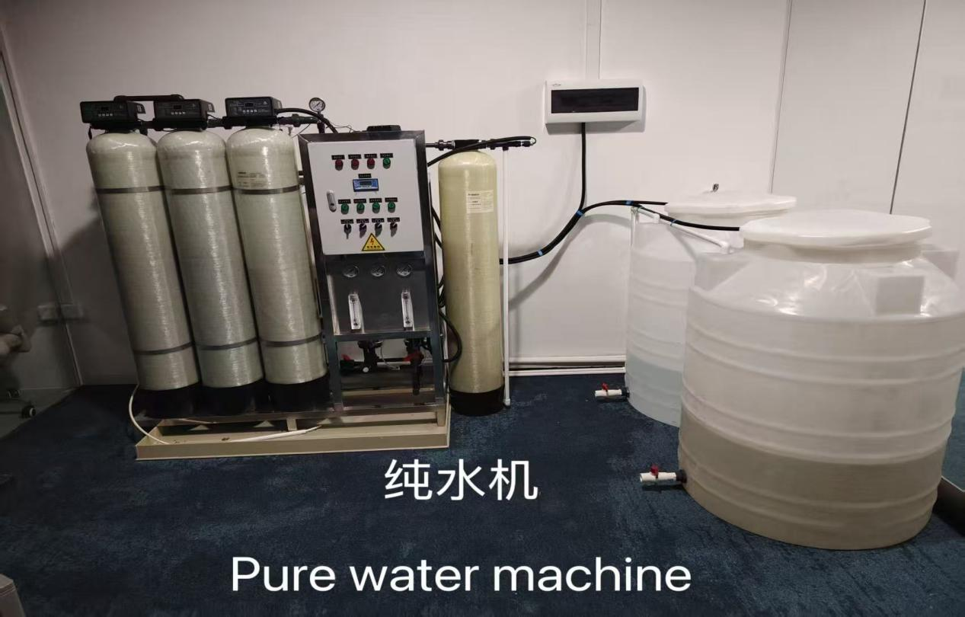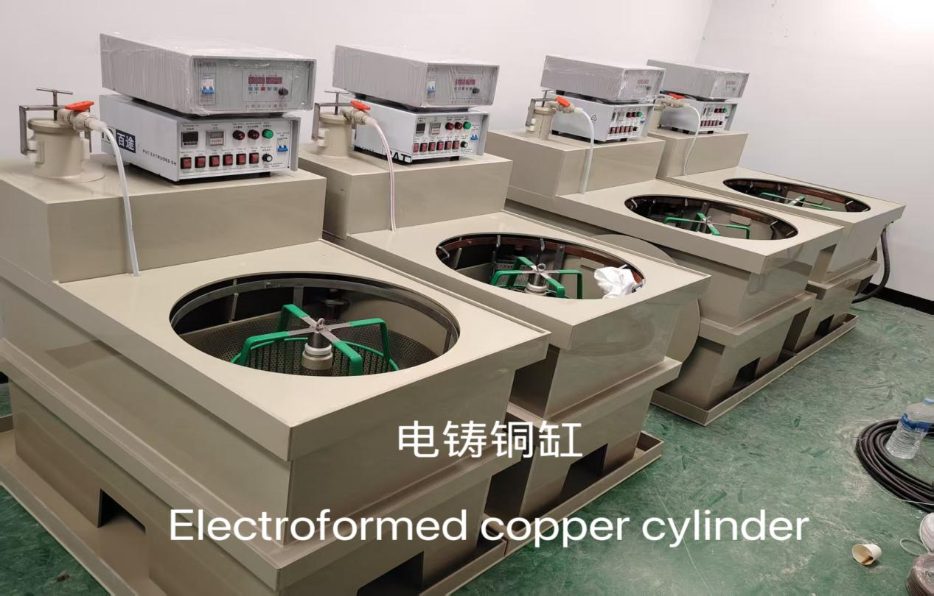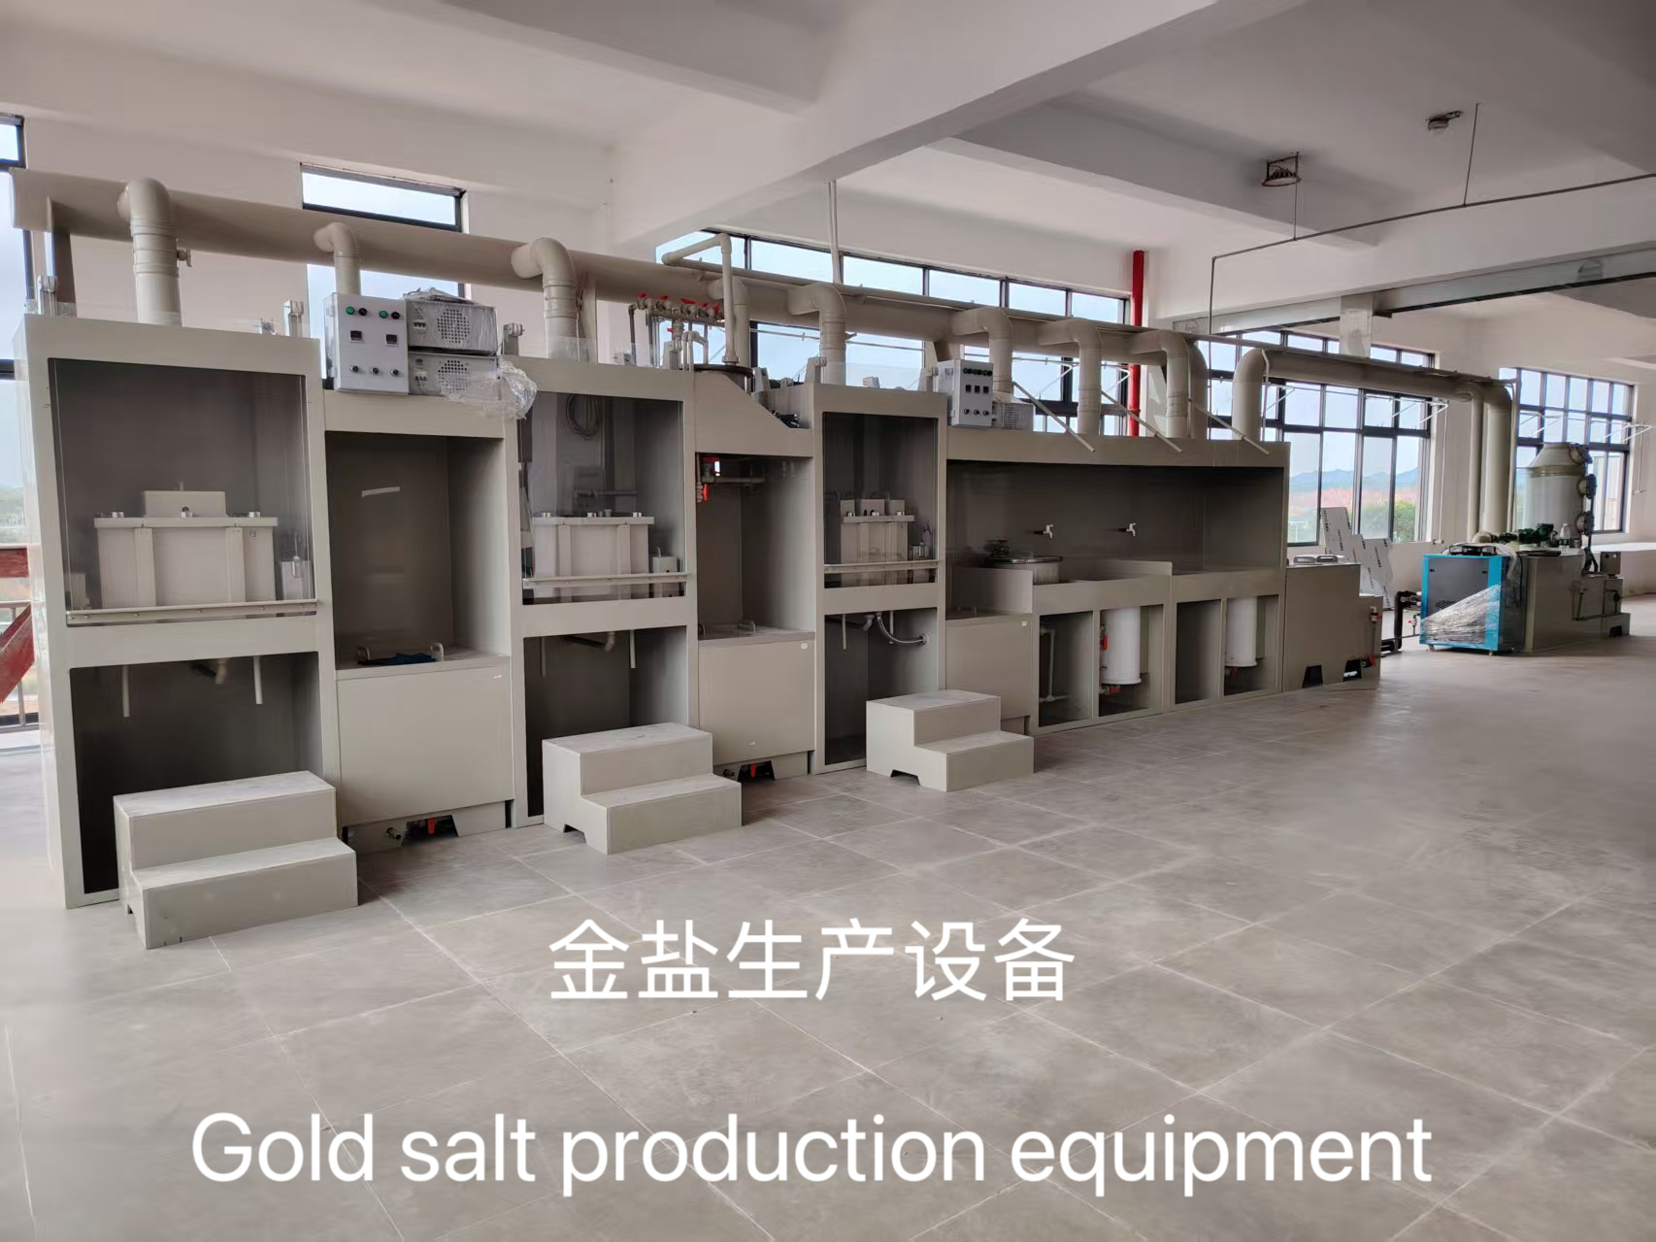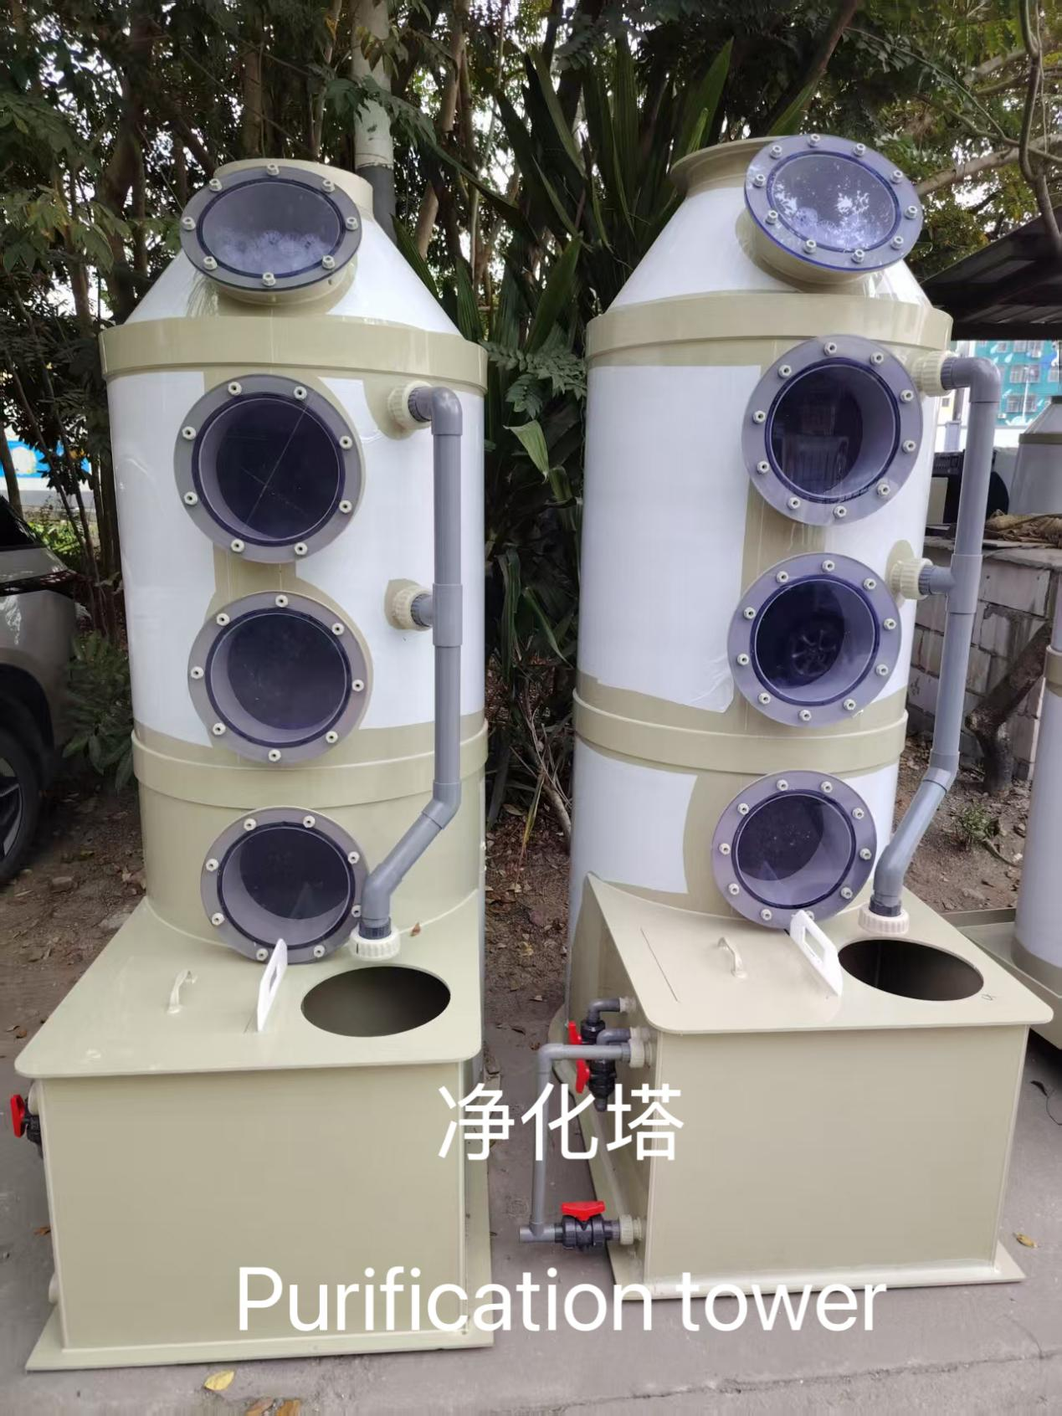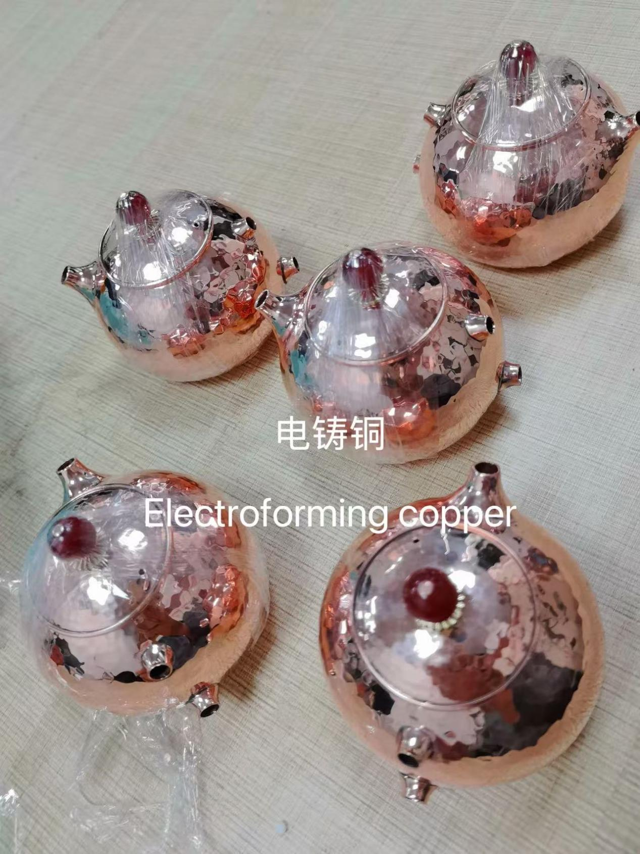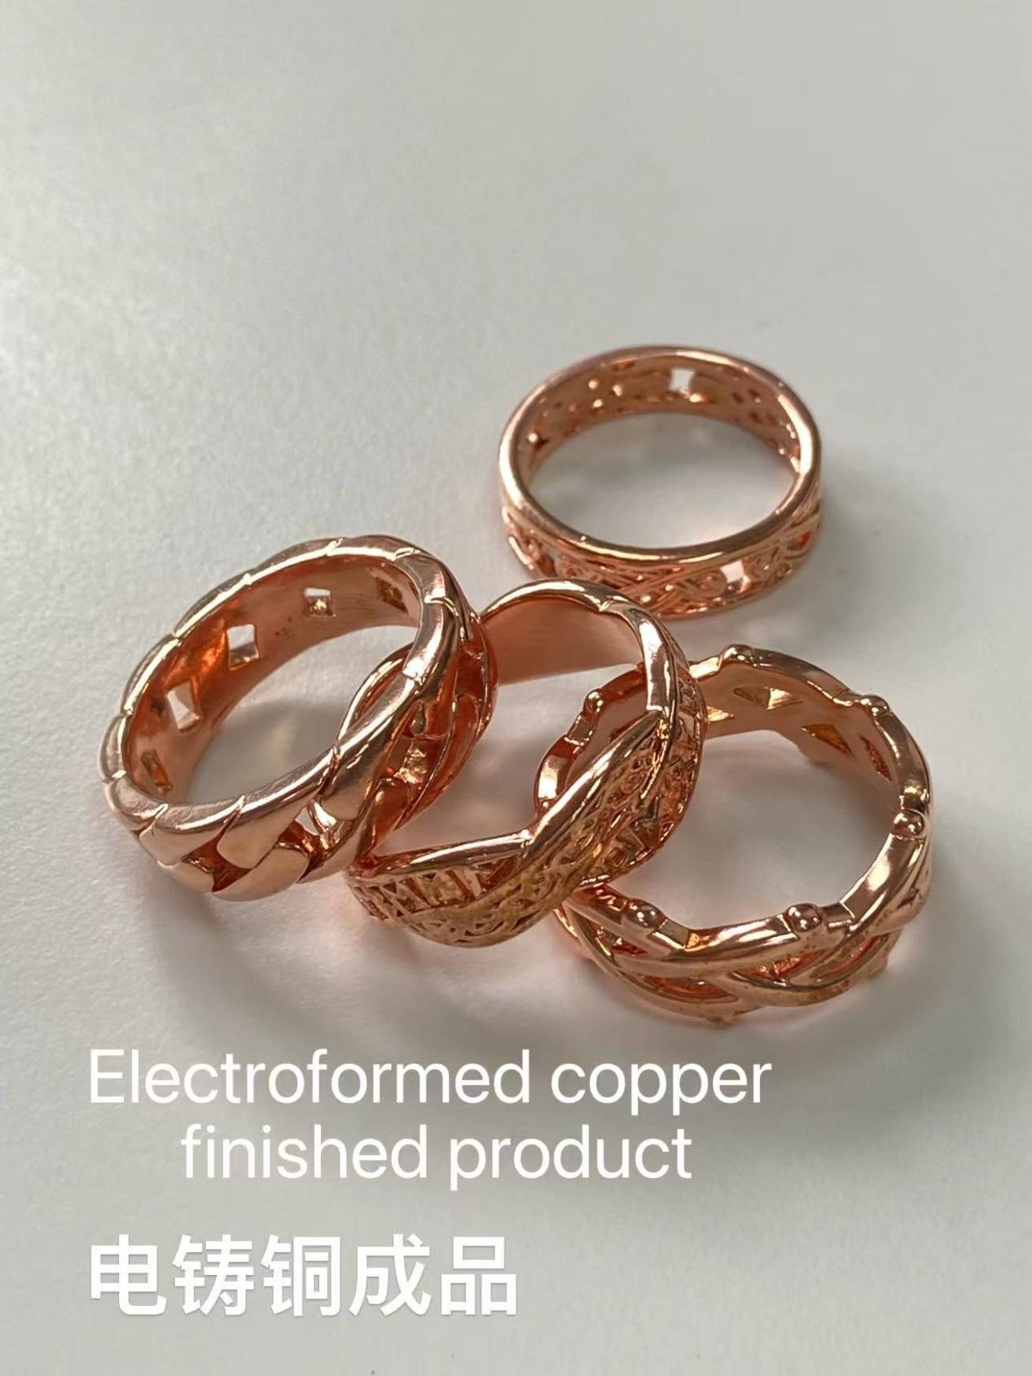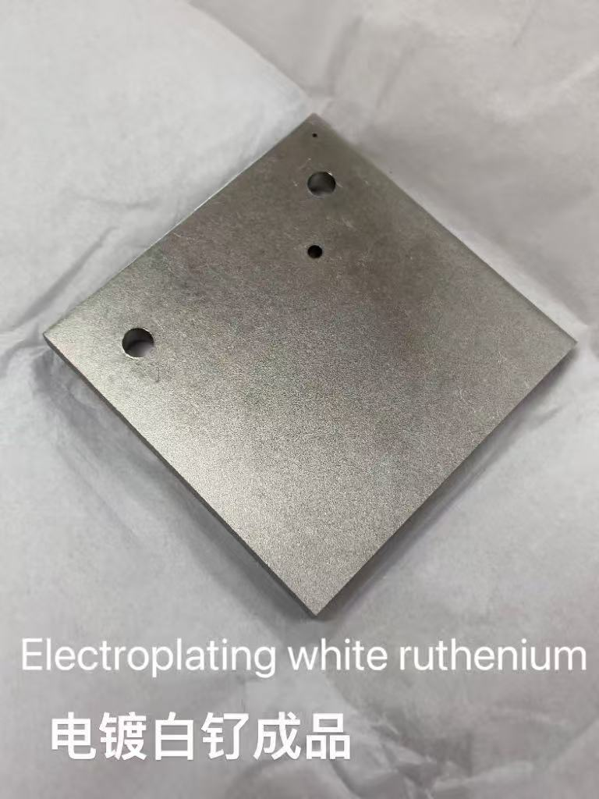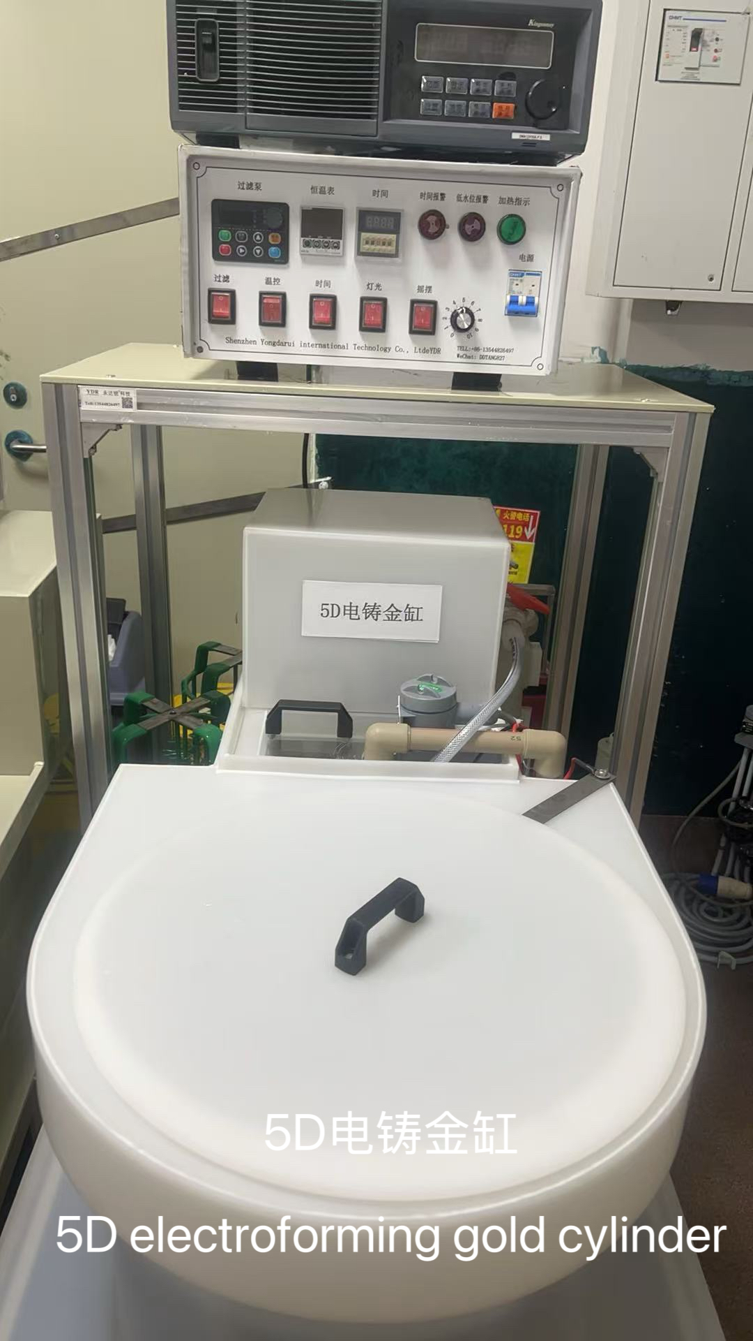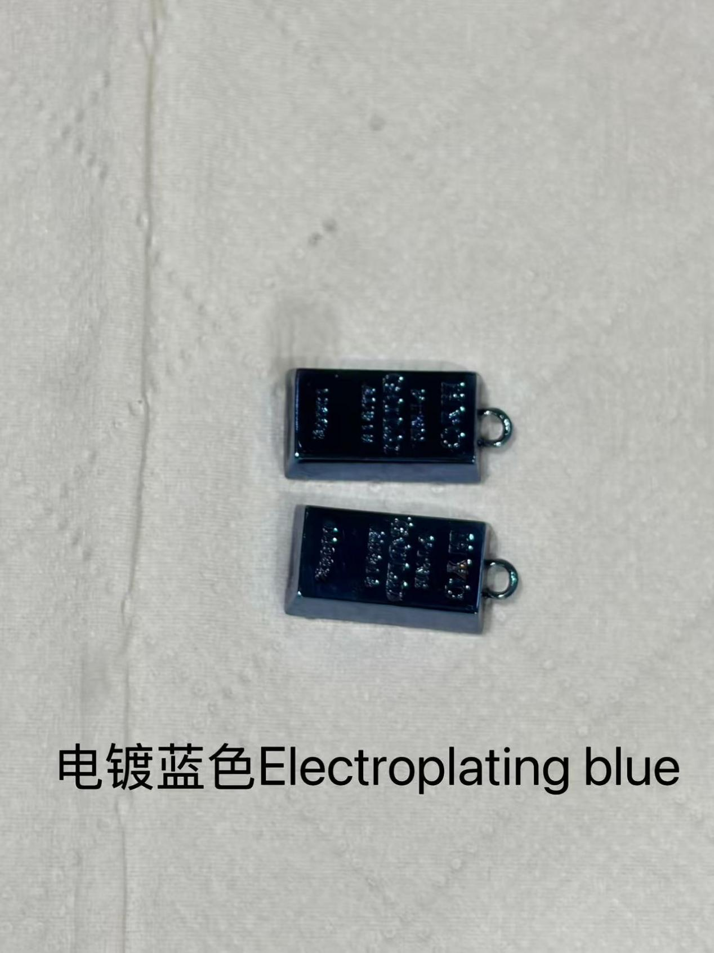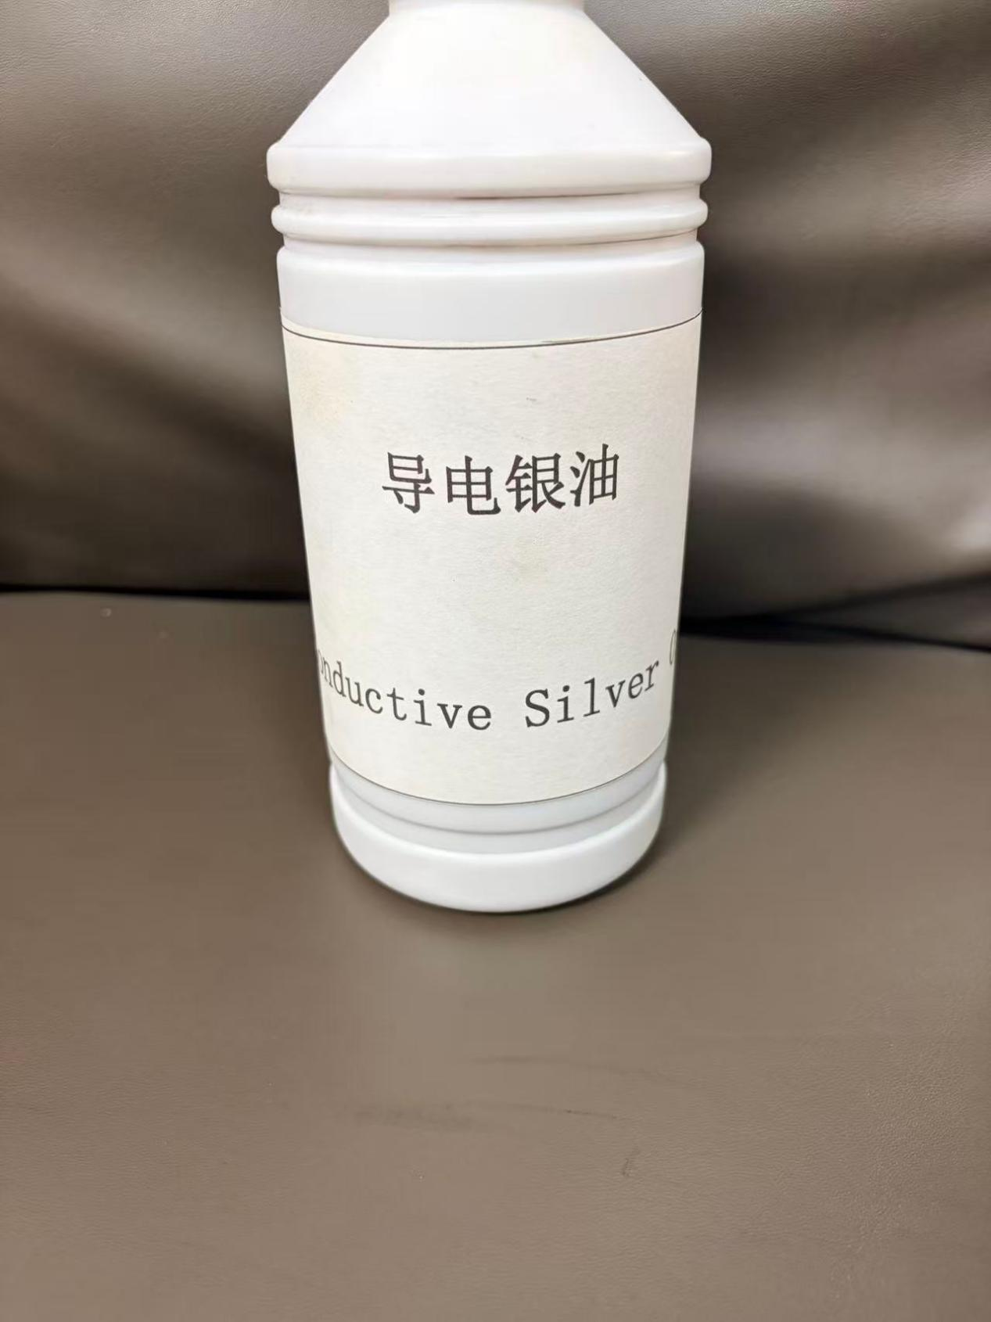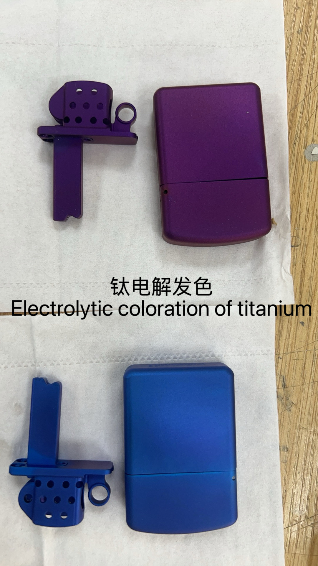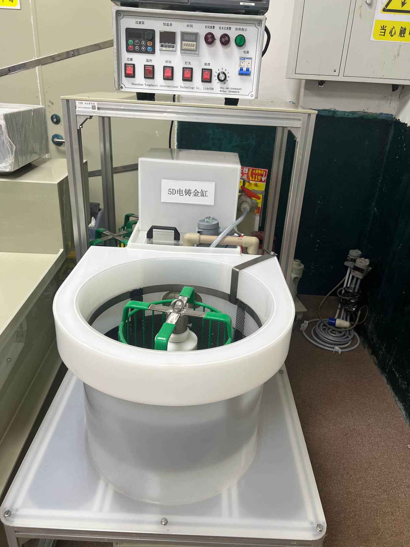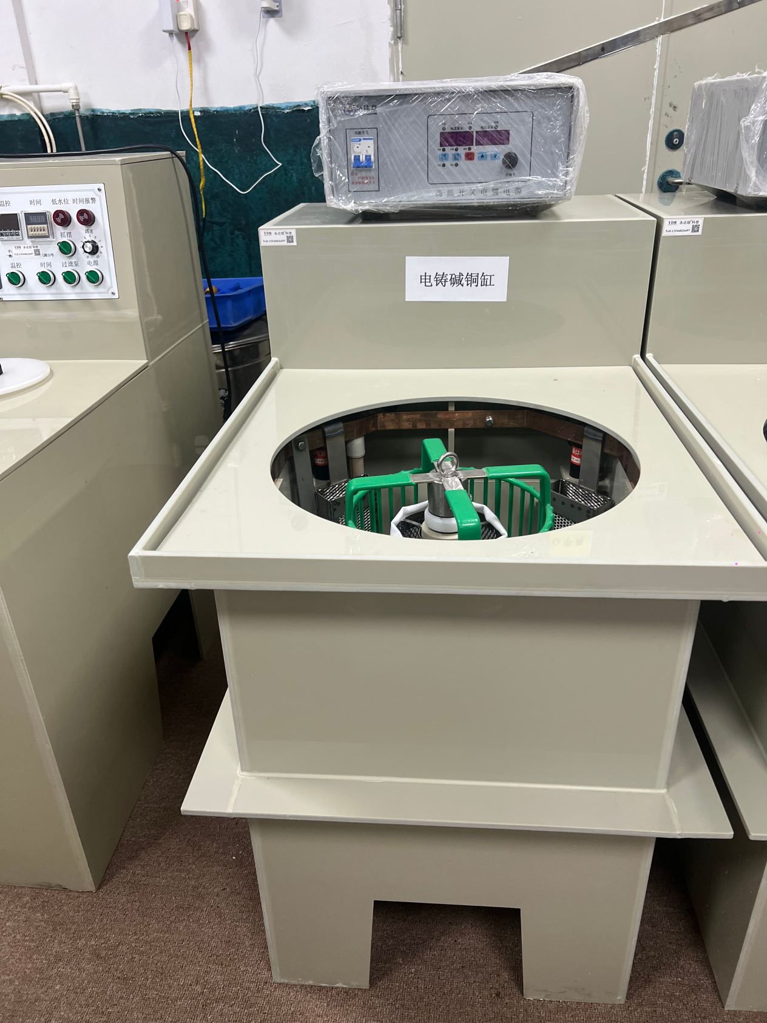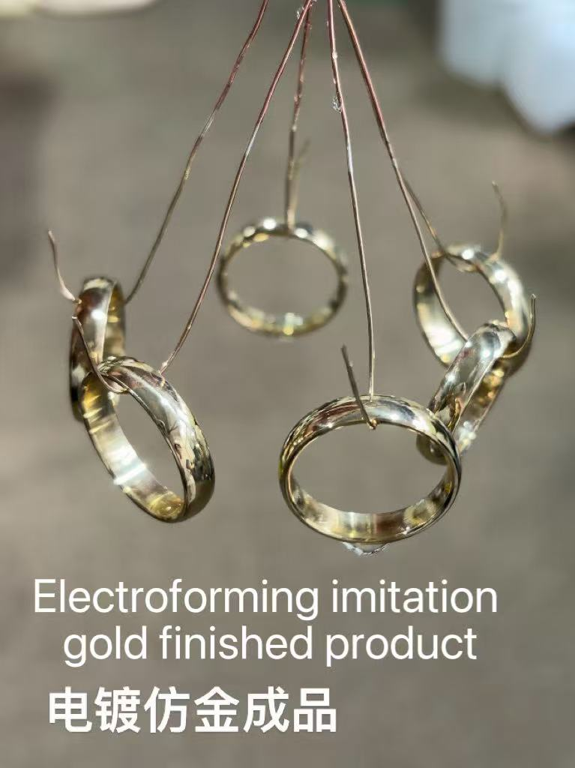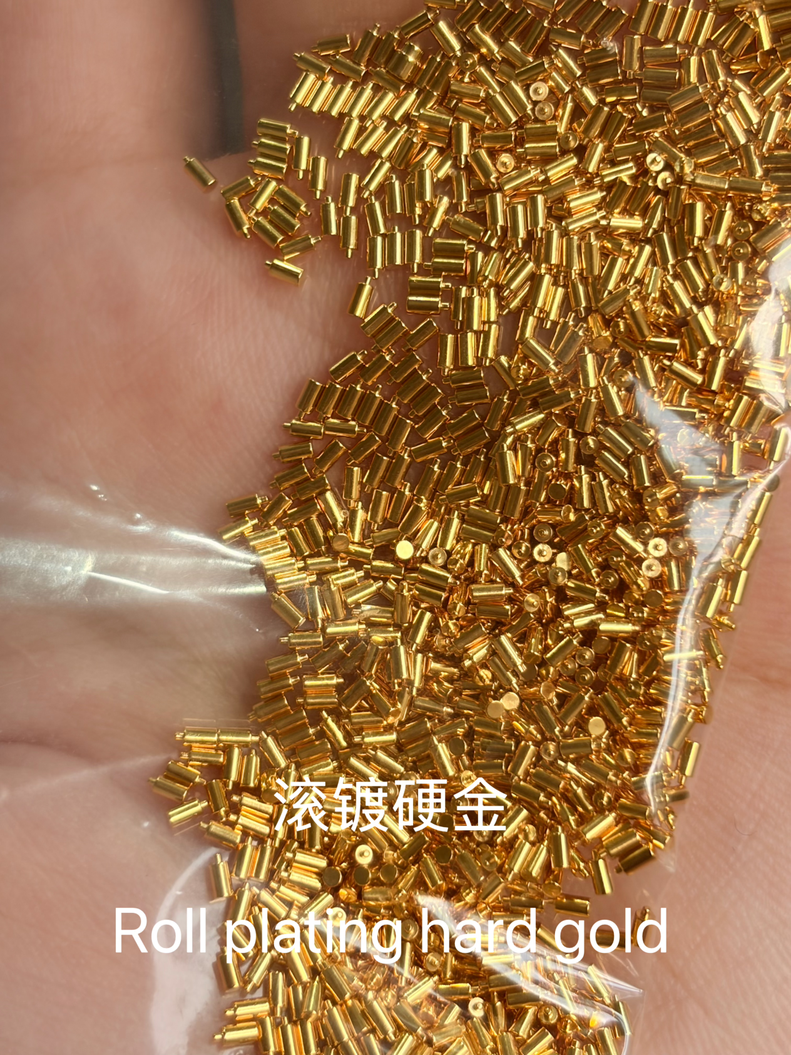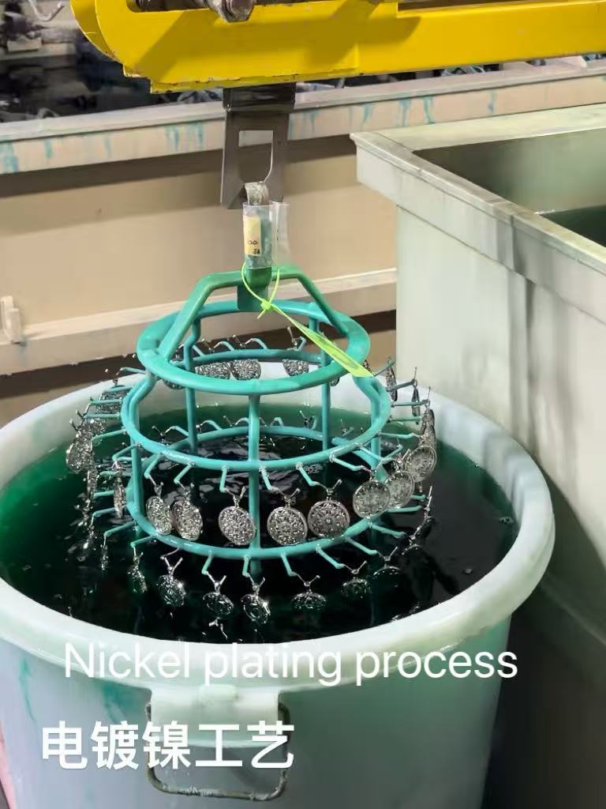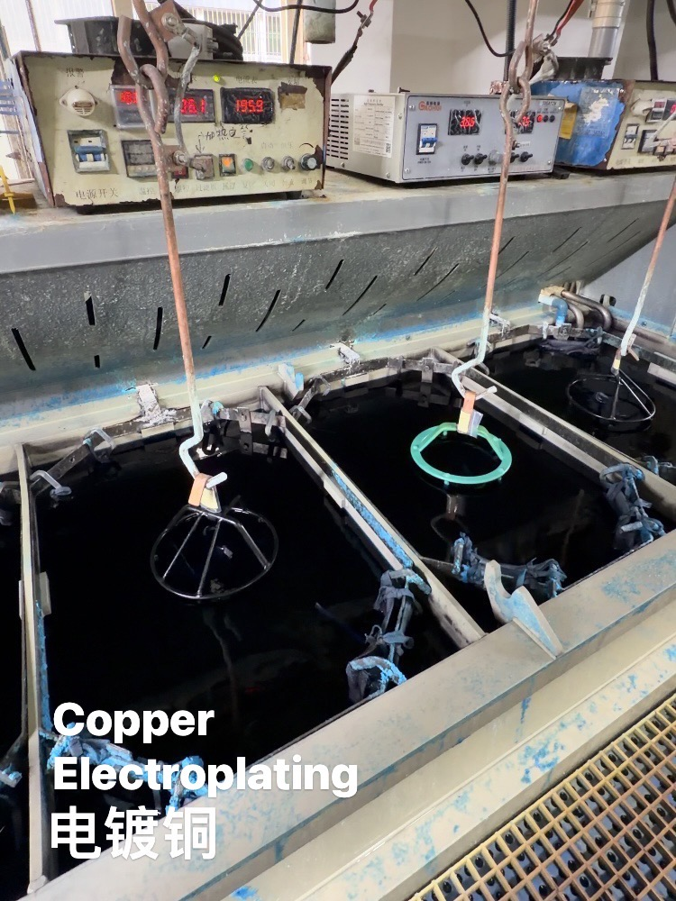1

